**Table of Contents**

Part 1 6

1.1 History & Architecture Evolution of Distributed Computing 6

1.1.1 History 6

1.1.2 Architectural Evolution 9

1.2 Enterprise Application & Architecture 13

1.2.1 Enterprise Application 13

1.2.2 Application Architecture 17

1.3 Existing Enterprise Resource Planning Solution 20

1.4 Selection of APU System to Implement Architecture 24

1.4.1 APU Systems 24

1.4.2 Justification 26

1.5 Application of Architecture & System Improvements 27

Part 2 30

2.1 Design of Web Components 30

2.1.1 Java Server Pages (JSP) 30

2.1.2 Servlet 33

2.2 User Manual 35

2.2.1 Webpage Design 35

2.2.2 Site Map & Navigation Chart 42

Part 3 44

3.1 Overview of Web Application 44

3.2 Design of Business Tier 45

3.3 UML Diagrams 48

3.3.1 Use Case Diagram 48

3.3.2 Class Diagram 49

Part 4 50

4.1 Database Design 50

Part 5 54

5.1 Additional Features 54

5.1.1 CSS 54

5.1.2 MySQL Database Management System 57

5.1.3 Date Picker 58

References 59

**Table of Figures**

Figure 1 History of Distributed Computing (Lindsay et al., 2021) 8

Figure 2 Fog Computing Code Snippet (Karakaya & Akleylek, 2021) 9

Figure 3 SOA Conceptual Model (Fernando, 2018) 10

Figure 4 WebOTX Enterprise Service Bus (NEC Corporation, n.d.) 10

Figure 5 Application Programming Interface (API) (Fernando, 2018) 11

Figure 6 Virtual Machines & Containers (Fernando, 2018) 11

Figure 7 Microservices Architecture (MSA) (Fernando, 2018) 12

Figure 8 Kubernetes (Fernando, 2018) 13

Figure 9 Kubernetes Listing Pods Code Snippets (Kim, 2021) 13

Figure 10 Enterprise System Structure before ERP Implementation (Kawalpreet, n.d.) 14

Figure 11 Enterprise System Structure after ERP Implementation (Kawalpreet, n.d.) 15

Figure 12 Oracle ERP Cloud Example (Hayes, 2022) 15

Figure 13 Odoo CRM Software Example (Odoo, 2022) 16

Figure 14 Sonatype Nexus SCM Example (Huchthausen, 2015) 17

Figure 15 Sonatype Nexus Open-Source Code Snippets (Sonatype-zion, 2016) 17

Figure 16 Three-tier Architecture (Amini & Abukari, 2020) 18

Figure 17 Sample Code in Data Tier (Pandit, 2016) 19

Figure 18 Sample Code in Business Logic Tier (Pandit, 2016) 19

Figure 19 Sample Code in Presentation Tier (Pandit, 2016) 19

Figure 20 Event-driven Architecture (Azure Architecture Center, n.d.) 20

Figure 21 Cloud Architecture for ERP Solution (Amini & Abukari, 2020) 20

Figure 22 ERP Software Companies Worldwide Market Share in 2021 (Vailshery, 2022) 21

Figure 23 Structure of Microsoft Dynamics 365 Business Central (Microsoft, 2022) 22

Figure 24 Dynamics 365 Business Central Three-tier Architecture (Microsoft, 2022) 23

Figure 25 Sample Code for Custom Workflow Activity Using Dynamics 365 (Reddy, 2017) 24

Figure 26 Web-based APSpace User Interface (Asia Pacific University, 2022) 25

Figure 27 APU Knowledge Base Structure (Asia Pacific University) 26

Figure 28 APSpace Bitbucket Code Snippets (Rahman, 2022) 26

Figure 29 APU Three-tier Architecture 28

Figure 30 Presentation Tier Code Snippet (Martin, 2022) 29

Figure 31 Business Logic Tier Code Snippet (Martin, 2022) 29

Figure 32 Data Tier Code Snippet (Martin, 2022) 30

Figure 33 Interaction between Web Application Server, HTML, and JSP (Tyson, 2019) 31

Figure 34 JSP used for Login Page (Part1) 32

Figure 35 JSP used for Login Page (Part2) 33

Figure 36 Servlet Architecture (Chauhan, 2021) 34

Figure 37 Servlet used for User Login 35

Figure 38 Login Page 36

Figure 39 Register Page 36

Figure 40 Error Page 37

Figure 41 Manager Home Page 37

Figure 42 Reporting Functionality 38

Figure 43 Edit Profile Page 39

Figure 44 Success Notification Page 39

Figure 45 Manage Staff and Customer Page 39

Figure 46 Add Staff Page 40

Figure 47 Fail Notification Page 40

Figure 48 Manage Booking Page 40

Figure 49 History Booking Page 41

Figure 50 Receipt Page 41

Figure 51 Assign Booking Page 41

Figure 52 Staff Home Page 42

Figure 53 Update Booking Status Page 42

Figure 54 Customer Home Page 42

Figure 55 Create Booking Page 42

Figure 56 Edit Booking Page 42

Figure 57 Rating Page 42

Figure 58 Site Map 43

Figure 59 Navigation Chart 44

Figure 60 Enterprise JavaBeans (Anamika Kalwan, 2019) 46

Figure 61 Entity Beans Code Example 47

Figure 62 Session Beans Code Example 48

Figure 63 Use Case Diagram 49

Figure 64 Class Diagram 50

Figure 65 Entities in Database 51

Figure 66 XAMPP Control Panel 51

Figure 67 SQL Query for Initializing Database 52

Figure 68 Entity Relationship Diagram (ERD) 54

Figure 69 Tailwind CSS Code Example 55

Figure 70 Register Page Designed using Tailwind CSS 56

Figure 71 Bootstrap Code Example 57

Figure 72 Error Page Designed using Bootstrap 57

Figure 73 Database URL, Username, and Password Stored in web.xml 58

Figure 74 Passing Parameters to mainServlet.java 58

Figure 75 Date Picker in Register Page 59

# Part 1

## History & Architecture Evolution of Distributed Computing

### History

Distributed computing, a concept that appeared in the 1960s during the Cold War, was invented by Paul Baran to improve communication among the United States militaries. On that occasion, it acted as the most secure communication method to exchange the data through a network of switching nodes, and the messages will only stop at the final destination. Each node in the distributed communication network is a computer as it is more intelligent than a telephone switch when determining the best route to transmit the information. As a result, more and more nodes and connections will result in redundancy, and the messages will be broken into small, uniform blocks and reach the destination through many different paths. As a result, the messages can be conveyed simpler, smoother, and more efficiently. It is the foundation of today’s Internet showing the network designs called message block switching or packet switching (Abbate, 1999; Ahn et al., n.d.).

The first distributed systems, local-area networks (LAN) such as ARPANET, were commenced in the 1970s. At that time, ARPANET connected all the latest computer equipment from different locations into a single network to maximize efficiency. Through the nodes of ARPANET, the first network virus called Creeper and the initial antivirus called Reaper were invented and were the first distributed computing programs (Ahn et al., n.d.).

In 1973, Vint Cerf invented the fundamental architecture of the Internet used to interconnect local network devices, called Transmission Control Protocol/Internet Protocol (TCP/IP). After that, more and more hosts started getting involved in the network, and many modern network technique inventions were built upon the TCP/IP protocol (Singel, 2012). In 1985, the formalization of the Domain Name System (DNS) aimed to convert the host domain names to IP addresses, was first implemented by Unix BIND software (Lindsay et al., 2021).

World Wide Web (WWW), a representative of distributed computing, was then introduced in 1989 and accelerated the growth of the Internet and its users. The first International World Wide Web conference was held in May 1994, the “Year of the Web” (“A short history of the Web,” n.d.; Lindsay et al., 2021). The peer-to-peer(P2P) system that splits the clients and servers into equivalent parts in order to balance the workload while performing large-scale processing emerged in 1999. Examples of pioneering P2P Software are Napster, Seti@Home, and others (Lindsay et al., 2021).

Currently, distributed computing is led by cloud computing technology, allowing individuals or businesses to utilize the available computing resources from applications to storage supplied by cloud service providers. Many popular tech companies have already developed and provided their own cloud services, such as Amazon Web Services (AWS), Microsoft Azure, Google Cloud, and others. One of the best benefits of cloud computing is its pay-per-use business mode that provides on-demand services resulting in a cost-effective, scalable, and flexible method (Lindsay et al., 2021; Ranger, 2022).

Since the emergence of the Internet of Things (IoT) and mobile computing, the need for real-time data collection and processing has increased and motivated the idea of fog and edge computing. Edge computing is a paradigm bringing data storage and computation nearer to the client endpoint, such as IoT devices, while fog computing plays the role of middleman between the edge and the cloud (Lindsay et al., 2021; Overheid, 2022). The diagram below shows the history of distributed computing, starting from traditional packet switching to modern edge computing.

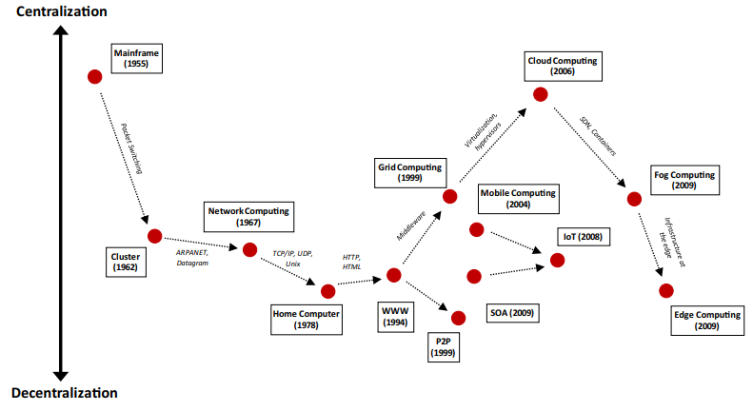

Figure 1 History of Distributed Computing (Lindsay et al., 2021)

As time goes by, the application of distributed computing has become more widespread to satisfy the demand for increasing data. Being the mainstream of the current generation of computing, a distributed system that assists the data transmission across multiple computers is able to reduce operational costs and time eventually compared to a traditional single mainframe system. Besides, it can achieve better scalability and reliability, as well as low latency in the computers’ communication process. However, it also comes with limitations, such as higher security risk, overhead, and complexity, that should be overcome in the coming future (Room, 2021).

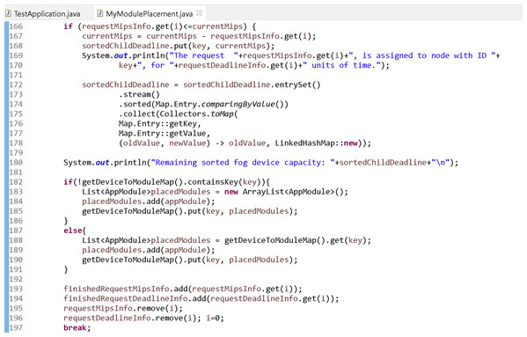

Figure 2 Fog Computing Code Snippet (Karakaya & Akleylek, 2021)

### Architectural Evolution

Before the emergence of distributed computing, a mainframe computer could only perform a specific job at a time. Therefore, to proceed with various tasks in parallel, multiple computers must be running simultaneously. However, executing those tasks in parallel requires a method for the participating computers or computer programs to communicate with one another. Hence, message-oriented communication has arisen in which two computers are able to transmit a message that encapsulates the data to each other (Fernando, 2018).

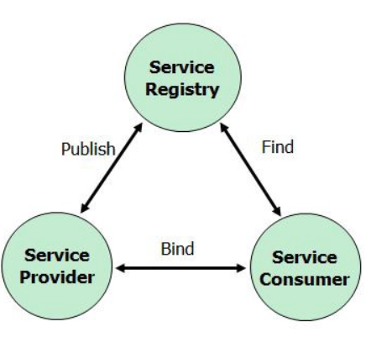

Figure 3 SOA Conceptual Model (Fernando, 2018)

To achieve multitasking, the developers tried to develop a distributed system combining several computers via messaging. Instead of point-to-point interaction between applications, Service-oriented Architecture (SOA), which splits the functions into small units or services accessible over a network, allows reusability of software components and interoperability via service interfaces. For the client-side implementations, the service consumers utilize the service interfaces from a Web Service Description Language (WSDL) describing web services based on Extensible Markup Language (XML) (Fernando, 2018; IBM Cloud Education, 2021).

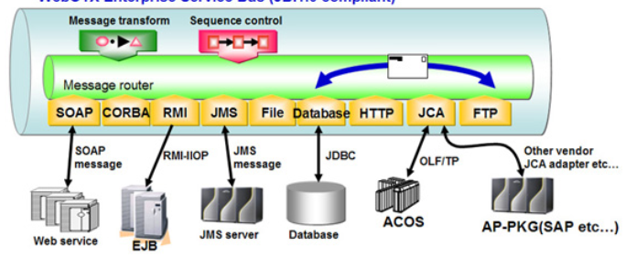

Figure 4 WebOTX Enterprise Service Bus (NEC Corporation, n.d.)

As more and more businesses get involved in SOA-based applications, the service connections become unscalable and unsustainable. Hence, it triggered the idea of a centralized “Service Bus” connecting numerous systems through a hub-like architecture named Enterprise Service Bus (EBS). In addition, EBS plays an essential role in translating the messaging formats and protocols that various systems use to communicate (Fernando, 2018).

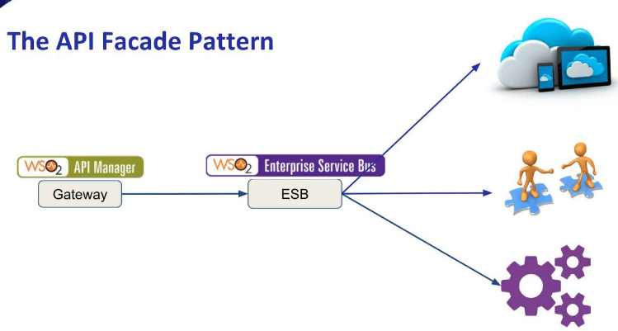

Figure 5 Application Programming Interface (API) (Fernando, 2018)

The widespread usage of the REST-based communication model due to the widespread Internet prompted the development of the Application Programming Interface (API). The REST architecture’s simplicity made it necessary to enhance its caching, monitoring-type features, and security. Rather than independently developing these features at each API, it is necessary to have a single component to apply these capabilities above the API. Currently, API architecture is still one of the fundamental components of all distributed systems (Fernando, 2018).

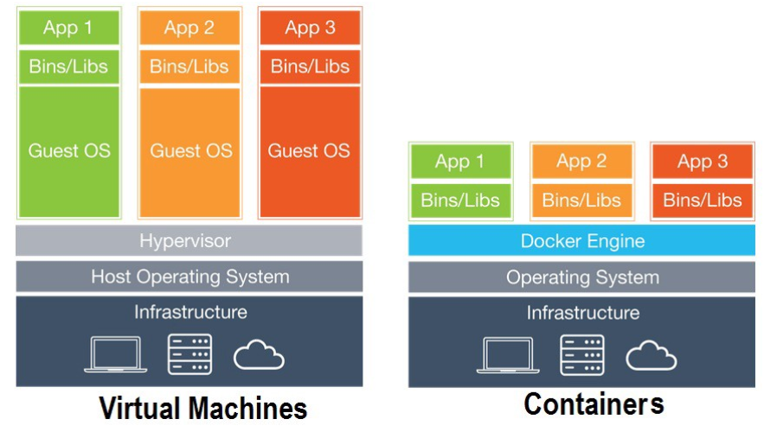

Figure 6 Virtual Machines & Containers (Fernando, 2018)

The virtual machine concept appeared to realize the ambition of internet-based companies, such as Netflix, Amazon, and Google, that develops distributed systems that spread across several data centres worldwide. Therefore, they decided to create various computers inside a virtual machine. However, the main drawback is resource exhaustion of the host computer that runs multiple operating systems in a virtual machine (Fernando, 2018).

Hence, they invented the containers that use the same host operating system kernel (Linux) to execute different programs and their necessary dependencies on district runtimes. Without the overhead of separated operating systems, the containers have functionality similar to virtual machines. This idea gained popularity and triggered the emergence of container-based application deployment. Some examples of container building platforms include Docker and Rocket (Fernando, 2018).

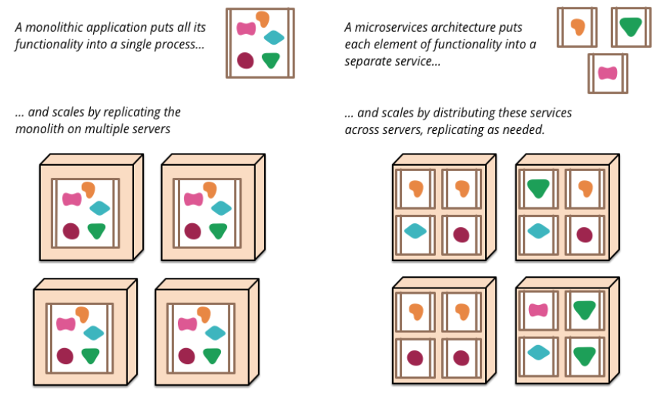

Figure 7 Microservices Architecture (MSA) (Fernando, 2018)

In 2005, Dr. Peter Rogers introduced the Microservices architecture (MSA) to increase the MSA-based application scalability and enhance rapid test processes. Microservices architecture breaks an extensive application into its most minor independent components that retain their own responsibilities. This architecture simplifies the communication with the distributed systems and makes them more consistent (Fernando, 2018; Mauersberger, 2017).

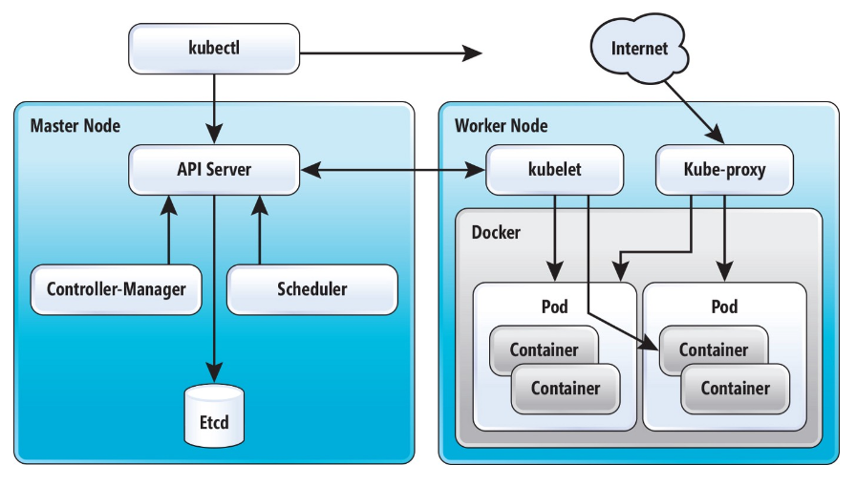

Figure 8 Kubernetes (Fernando, 2018)

Kubernetes (K8S), announced by Google in 2014, is designed to manage containerized workloads and services. It is an open-source container orchestration platform that allows software developers to run containers in massive clusters and automate application deployment and management of containerized applications. Currently, most enterprises implement the K8S technology because of its infinite scalability and various ecosystems, which includes numerous open-source frameworks for security, monitoring, and management (Fernando, 2018; Putz, 2021).

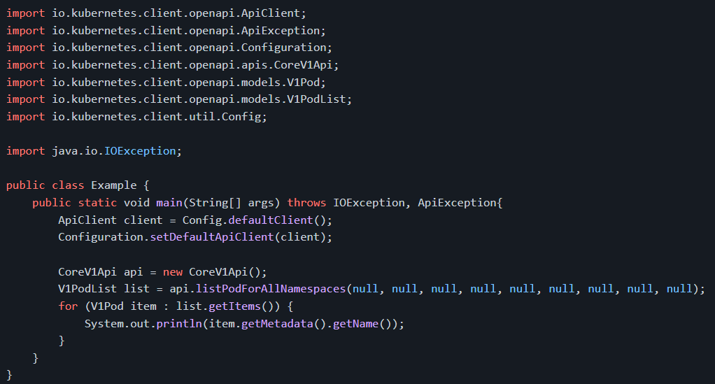

Figure 9 Kubernetes Listing Pods Code Snippets (Kim, 2021)

## Enterprise Application & Architecture

### Enterprise Application

The three main types of enterprise applications are Enterprise Resource Planning (ERP), Customer Relationship Management (CRM), and Supply Chain Management (SCM). ERP system utilizes the distributed computing concept to manage and integrate various functional areas of an enterprise and replace multiple standalone legacy systems. For example, the ERP system combines all of the required processes instead of separating planning software, marketing project management software, human resources management software, and others. It enables communication and data sharing across the enterprise departments with a single application. Integrating each part of an enterprise can achieve cost-efficiency as duplicated information and incompatible technology can be eliminated in order to minimize the system’s complexity (Anderson, 2022).

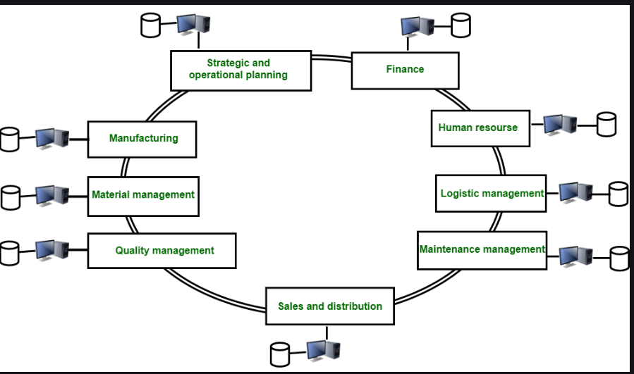

Figure 10 Enterprise System Structure before ERP Implementation (Kawalpreet, n.d.)

The diagram above is the graphical representation of multiple single systems managed by each business department before implementing an ERP solution. Every functional area has and manages its own database. It will create redundancy that leads to low productivity and efficiency due to the duplicated data (Kawalpreet, n.d.).

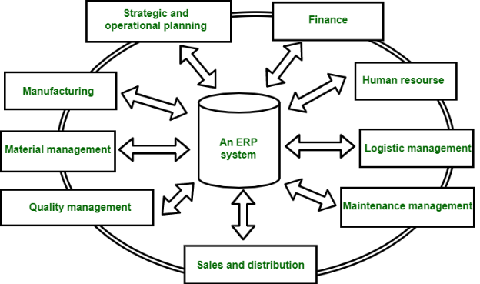

Figure 11 Enterprise System Structure after ERP Implementation (Kawalpreet, n.d.)

The figure above shows the implementation of an ERP solution within an enterprise that combines all the databases from different departments. This integration will synchronize the information and enable an employee from one department to access the information from the other departments achieving improved operations and transparency across the enterprise (Anderson, 2022; Kawalpreet, n.d.).

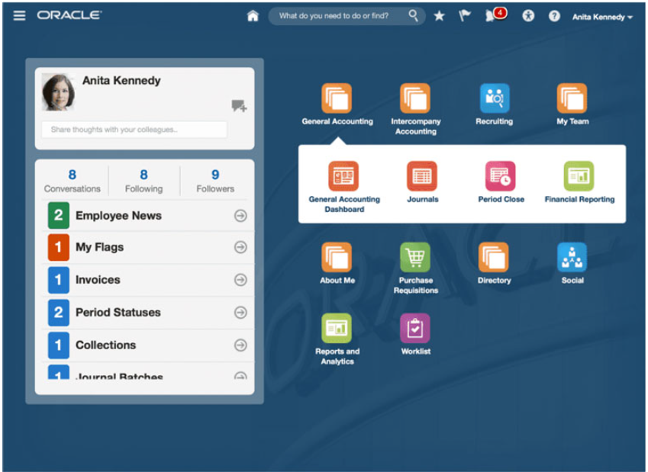

Figure 12 Oracle ERP Cloud Example (Hayes, 2022)

From the example diagram above, the ERP system integrates the functionality of recruiting by the human resource department, financial reporting by the finance department, general accounting dashboard by the accounting department, and others.

CRM is a system that assists enterprises in managing connections and nurturing relationships with current and prospective clients. CRM elements include enterprise websites, social media, emails, and telephone calls. The main objective of a CRM system is to increase profits by building better customer relationships. The system provides the approach to collecting the client data and analyzing the communication history in order to gain better insight and improve the business connections. Through the implementation of a CRM system, it is possible to both improve customer satisfaction and inspire their loyalty (Hargrave, 2020).

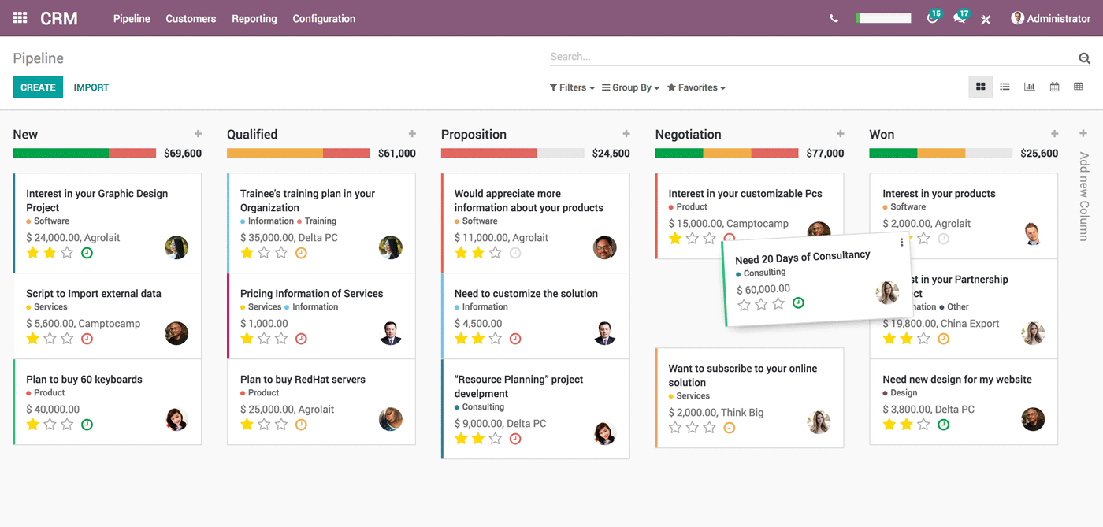

Figure 13 Odoo CRM Software Example (Odoo, 2022)

An SCM system is used to control the flow of goods, services, and activities, from acquiring raw materials to delivering the final product. SCM’s purpose is to optimize customer value and achieve a competitive edge in the market through controlling active streamlining of the supply-side activities of an enterprise. By achieving healthy management in the supply chain, an enterprise will be able to save operational costs and deliver its products faster and more efficiently. The supply chain processes include planning, sourcing, manufacturing, delivering, and returning. SCM helps to maintain a consistent standard in every stage of an enterprise’s supply chain, from the beginning of production to the final sale (Fernando, 2022).

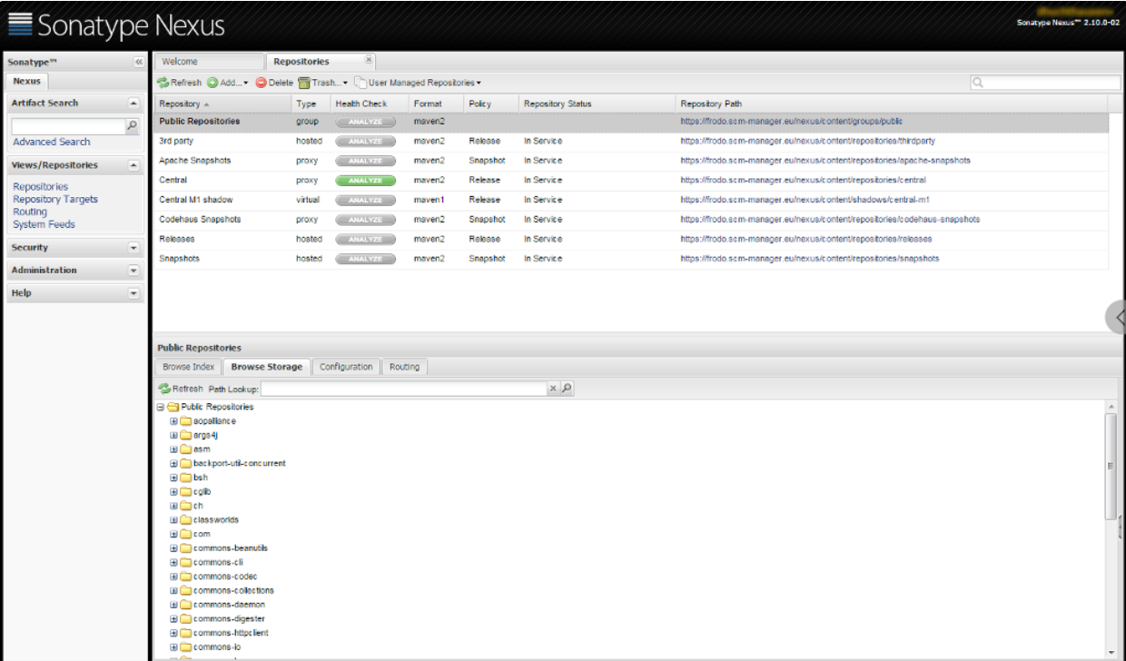

Figure 14 Sonatype Nexus SCM Example (Huchthausen, 2015)

All in all, all the enterprise applications, such as ERP, CRM, and SCM, are implemented to satisfy an enterprise’s needs and enhance the system’s efficiency and effectiveness. Therefore, choosing the proper application according to the business size, business type, and business goals is essential for maximizing enterprise growth.

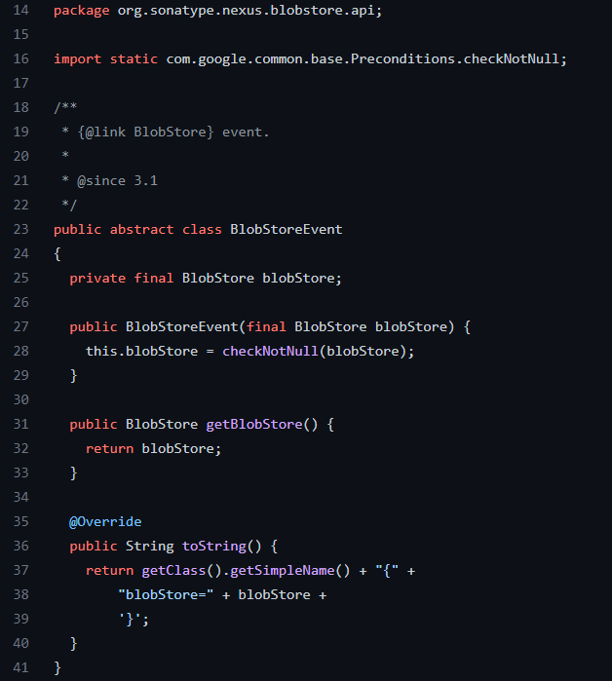

Figure 15 Sonatype Nexus Open-Source Code Snippets (Sonatype-zion, 2016)

### Application Architecture

To develop an enterprise application, a system architecture acting as a roadmap is required to illustrate the application structure and patterns. An architecture establishes the link among organizational components, such as enterprise structure, business rules, and people, with sophisticated information technology components, such as hardware, Software, and data. Some examples of application architectures include multi-tier architecture, event-driven architecture, cloud architecture, and others (Amini & Abukari, 2020; “What is an application architecture?”, 2020).

Multi-tier architecture, also called n-tier architecture, organizes each element of the enterprise systems in layers in order to effectively manage the complexity of the system’s functionality and enable scalability and flexibility for the enterprise demands. In addition, by dividing the resources into many tiers, the architecture can enhance system security and lower the possibility of system failure (Amini & Abukari, 2020).

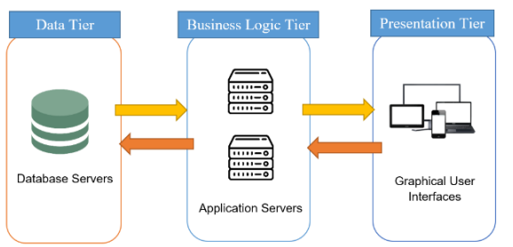

Figure 16 Three-tier Architecture (Amini & Abukari, 2020)

The diagram above shows the structure of the three-tier architecture. The data tier describes the database servers and the data repositories that are used to store information. The structure of all enterprise data and its interaction with both internal servers and external applications are included in this tier. The business logic tier, also called the application tier plays the most crucial role in implementing the business logic to process the information collected from the data tier and presentation tier. This tier consists of the servers and other components which enable the optimal performance for the essential functions. Lastly, the presentation tier, a top-level tier, presents the data in the correct formats and offers integration tools for supporting user interactions. It compromises an application’s user interface (UI), enabling communication with the application tier elements and the services they need (Amini & Abukari, 2020; Rehman et al., 2018).

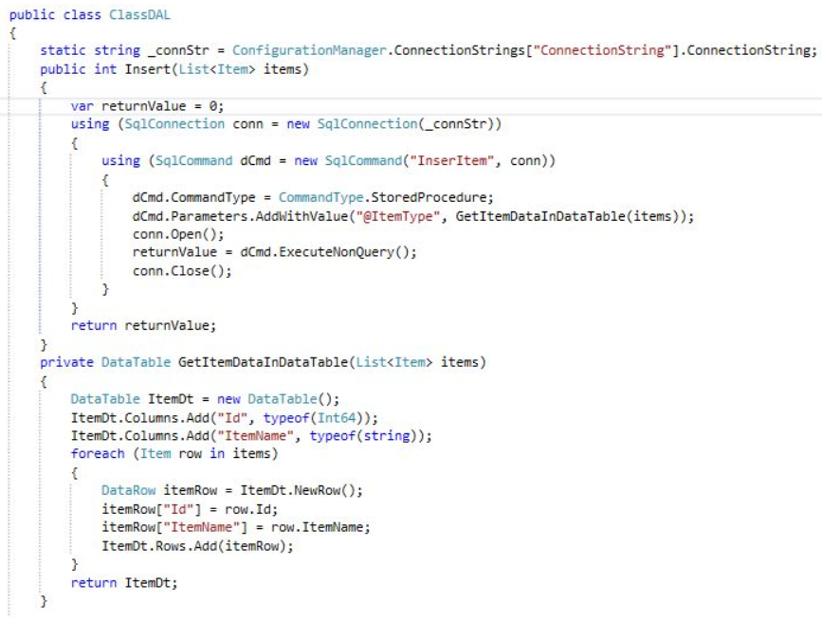

Figure 17 Sample Code in Data Tier (Pandit, 2016)

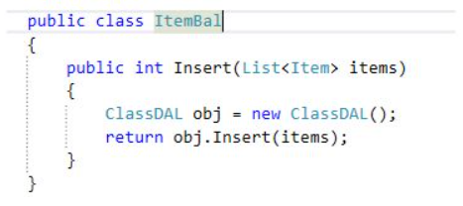

Figure 18 Sample Code in Business Logic Tier (Pandit, 2016)

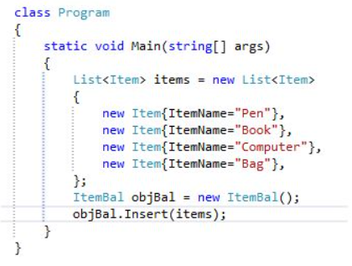

Figure 19 Sample Code in Presentation Tier (Pandit, 2016)

The event-driven architecture enables the information to convey across applications, microservices, and other connected devices in real-time when an event has been detected. Any noteworthy occurrence for system software or hardware, whether discovered from external or internal sources, is referred to as an event. Examples of “events” include new customer requests, detected abnormal temperature readings, changed stock prices, etc. Compared to the traditional request-driven model, the event-driven architecture can instantly react to the occurred event, achieving minimal coupling and providing a level of resiliency within the enterprise application (Jansen & Saladas, 2021).

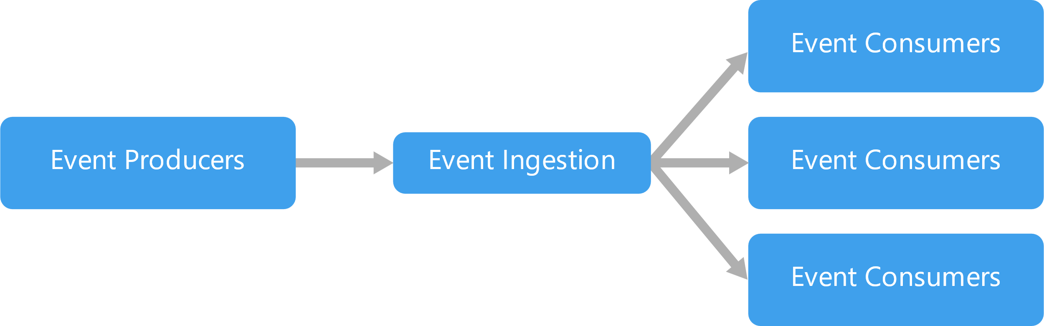

Figure 20 Event-driven Architecture (Azure Architecture Center, n.d.)

Event producers are responsible for detecting a new event and transmitting the event as a message to the event ingestion, which channels the message to the specific event consumers or reacts itself to the message for performing data preprocessing. In the end, after carrying out a series of preprocessing, the data will finally be sent to the event consumers for final processing (Azure Architecture Center, n.d.; Loganathan, 2019).

Cloud architecture is a modern distributed computing architecture that enables on-demand access to computing resources built on virtualization technology. With the Internet, an enterprise is able to access the virtualized resources supplied by cloud service providers whenever they want from any location in the world. The three types of services provided by cloud computing are Infrastructure as a service (IaaS), Platform as a service (PaaS), and Software as a service (SaaS) (Amini & Abukari, 2020). The figure below shows the overview of cloud architecture implemented in the ERP solution.

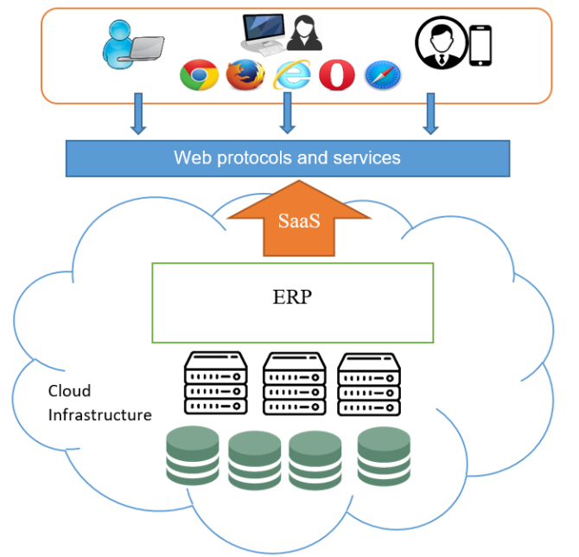

Figure 21 Cloud Architecture for ERP Solution (Amini & Abukari, 2020)

## Existing Enterprise Resource Planning Solution

Currently, there are many companies that provide ERP solutions with different architectures for developing enterprise applications. The chosen company for this investigation is Microsoft which provides Dynamics ERP solutions. In 2005, Microsoft Corporation introduced Microsoft Dynamics replacing Microsoft Business Solutions for providing ERP solutions to small, medium, and extensive enterprises in order to integrate and manage their financial, customer relationship management, and supply chain management (El-Sherif, 2014).

Currently, a new family of business software solutions named Dynamics 365 that was released in 2016 is used to combine the ERP and CRM products with the cloud computing technique and Artificial Intelligence features. One of the significant advantages of implementing the Microsoft Dynamics suite is its simplicity of integration with other well-known Microsoft products, including Microsoft Office, Microsoft Outlook, and Windows SharePoint Services (Amini & Abukari, 2020; Foley, 2016). According to the statistics carried out by Vailshery (2022), Microsoft Dynamics 365 market share is around 8.42% in providing ERP solutions worldwide in 2021, which is the second leading software company.

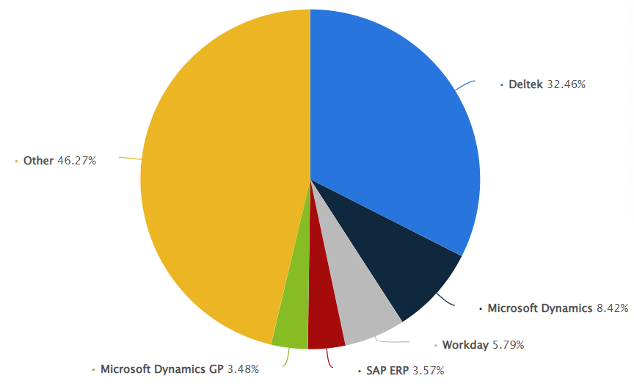

Figure 22 ERP Software Companies Worldwide Market Share in 2021 (Vailshery, 2022)

However, the Microsoft products that offer ERP solutions are Dynamics 365 Business Central, designed for small and mid-sized companies, and Dynamics 365 Finance & Operations, well-suited for large enterprises. They both provide cloud-based ERP software-as-a-service (SaaS) solutions leading to high flexibility and effectiveness. Besides, Microsoft also provides enterprises with the option to adopt these programs on-premises for particular requirements (Amini & Abukari, 2020). The diagram below shows the eight interconnected product modules that make up the Microsoft Dynamics 356 Business Central.

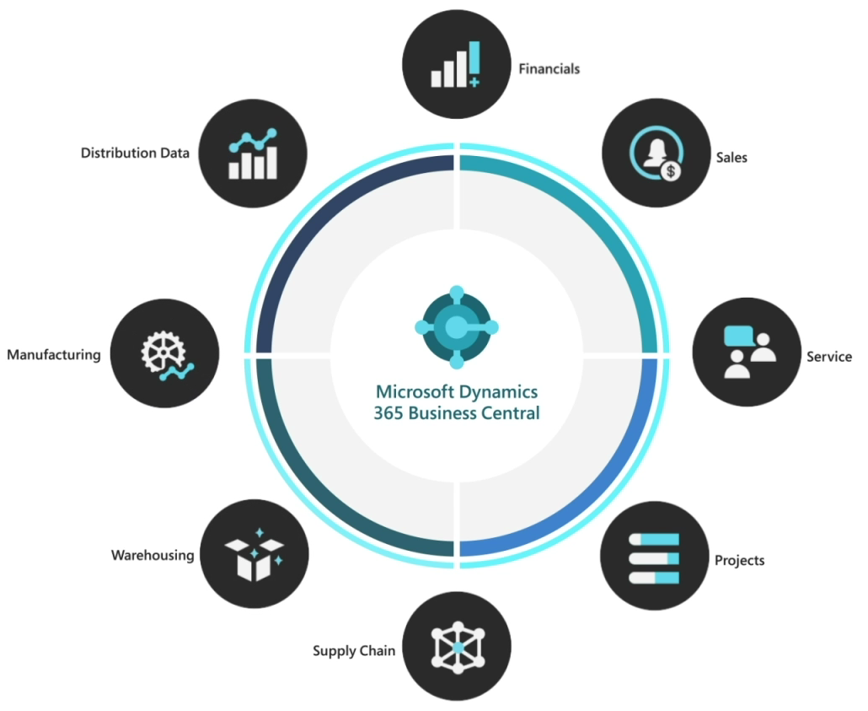

Figure 23 Structure of Microsoft Dynamics 365 Business Central (Microsoft, 2022)

From the perspective of application architectures, Microsoft Dynamics 365, both Business Central and Finance & Operations, conform to the three-tier architecture that organizes every component of the enterprise in layers or tiers. For example, for Dynamics 365 Business Central, web server (presentation tier), application server (business logic tier), and Microsoft Azure SQL Database (data tier) make up the enterprise application architecture. The web server components offer the ERP application modules to users via several web services managed by Microsoft Internet Information Services (IIS) in order to access the Business Central Web client and mobile apps. Besides, to customize the applications, the developers can also use the web services like SOAP and OData in order to get the data they need from the ERP application server (Amini & Abukari, 2020; Microsoft, 2022).

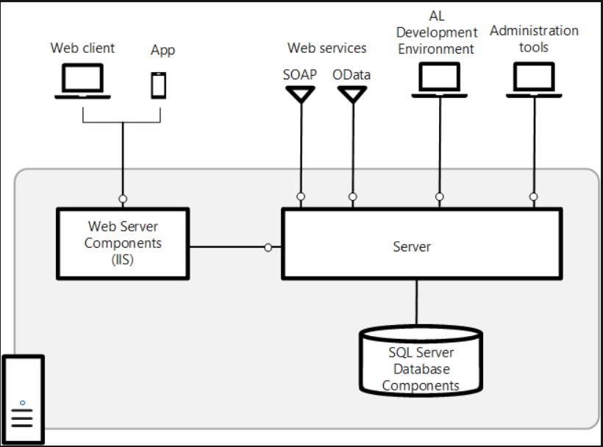

Figure 24 Dynamics 365 Business Central Three-tier Architecture (Microsoft, 2022)

From the diagram above, the AL development environment refers to the AL language extension for the applications and extensions development in Visual Studio Code. At the same time, the administration tool is used to generate the Business Central Server instances. Apart from that, the SQL server database allows the application and business data to be segregated into the various databases during a multitenant deployment as there will be various separated groups of users due to the integration of multiple departments. In this scenario, one or more tenants (users) can be connected to a single application database, and the tenant database will hold the business data (Microsoft, 2022).

The three-tier architecture embedded in an ERP solution is highly flexible and reliable as each layer can be managed separately when updating or performing modifications on the enterprise application without affecting other application areas. For example, regular maintenance on the business logic tier does not affect the presentation tier. As each tier is deployed in a horizontal direction, scaling out an application on numerous machines is relatively simple in order to meet the architecture’s scalability. Implementing three-tier architecture will improve the ERP system performance as the presentation tier can cache requests and achieve load reduction and minimum network utilization on the application tier and data tier. The sophisticated topology of this design allows high-speed data acquisition and low latency. Moreover, data is prevented from unauthorized access as the client lacks direct access to the databases resulting in high security of the ERP system (Grozev & Buyya, 2013; Insightsoftware Team, 2021; Sameena, 2021).

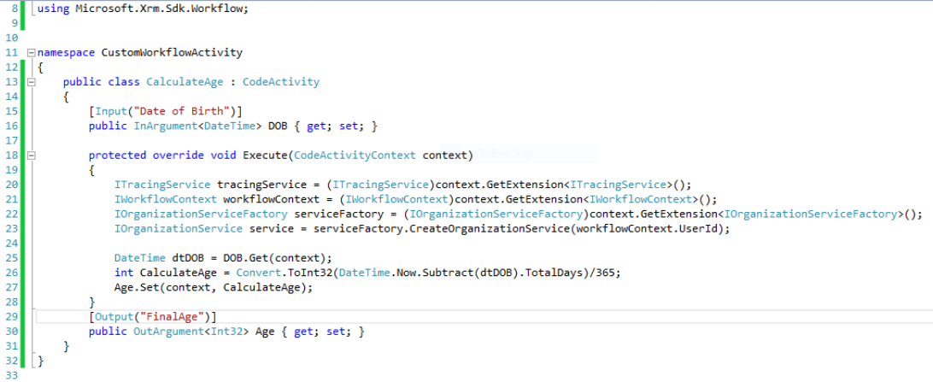

Figure 25 Sample Code for Custom Workflow Activity Using Dynamics 365 (Reddy, 2017)

## Selection of APU System to Implement Architecture

### APU Systems

Asia Pacific University of Technology and Innovation (APU), a private higher learning institution in Malaysia, has utilized several systems developed by other software companies and also developed its own system.

Moodle, an open-source learning management system, is implemented by APU to allow lecturers to assign homework, upload lecture notes, and release exam questions. It also lets students submit assignments, access learning materials, and sit for exams. Furthermore, APU developed its management system that combines all the applications, services, and systems from attendance management to library management, called APSpace. The features for university students include signing attendance, booking consultation slots, checking timetables, getting the latest news and information, checking APCard balance, viewing the shuttle bus schedule, finding the classroom, and others (Asia Pacific Univerisity, 2022).

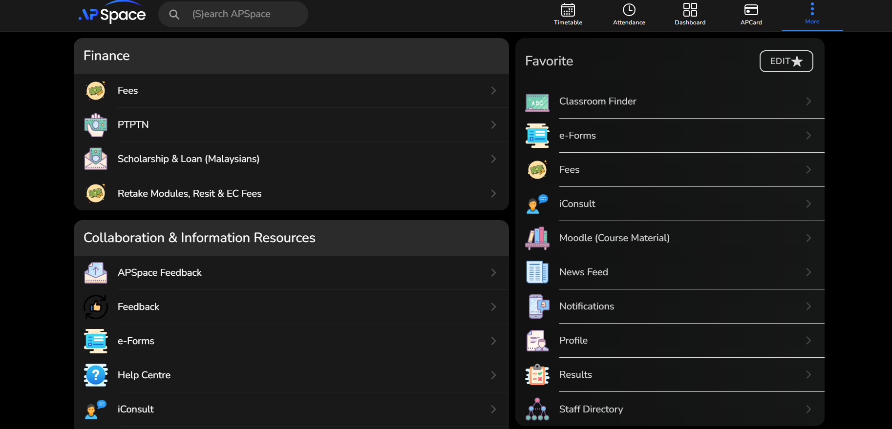

Figure 26 Web-based APSpace User Interface (Asia Pacific University, 2022)

Besides, APU has built a knowledge base acting as an information and document hub storing the data from academic and non-academic aspects. It supports APU staff and students to access the guidelines related to rules and regulations, module documentation, program documentation, internship, forms and templates, and others. A publicly accessible website application developed by APU consists of information, such as pre-university, undergraduate, and postgraduate courses, scholarship requirements, and the latest APU news. Students interested in taking one of the courses can apply for admission as an APU student and fill out the inquiry form through this website (Asia Pacific Univerisity, 2022).

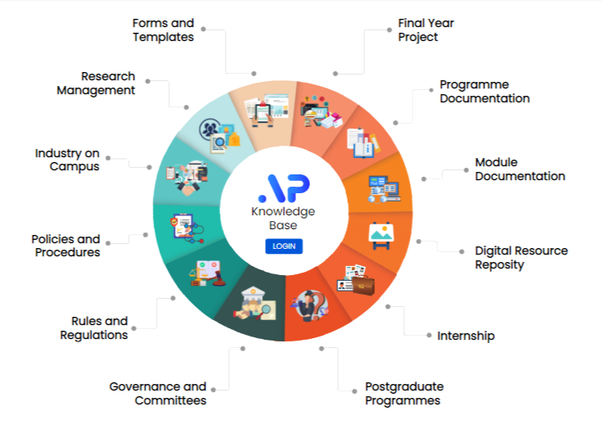

Figure 27 APU Knowledge Base Structure (Asia Pacific University)

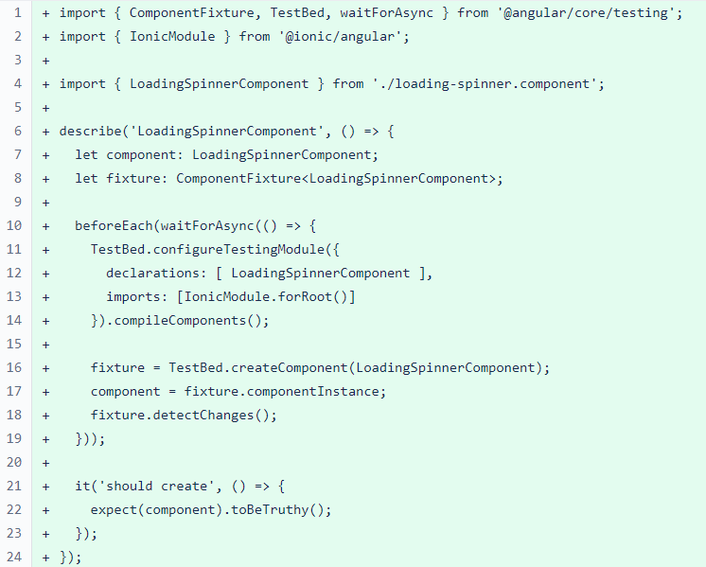

Figure 28 APSpace Bitbucket Code Snippets (Rahman, 2022)

### Justification

The selected APU system for implementing three-tier architecture is APSpace. It is because APSpace is able to connect all the APU students and staff from different departments, such as the financial department, human resources department, library department, lecturer department, and others, as they will have an APSpace account after enrolling in APU. It is similar to the ERP solution that integrates various departments of an enterprise. Moreover, three-tier architecture is the current trend for software application development. By implementing three-tier architecture in higher education ERP systems, the system security and scalability will be improved as well as the data integrity while performing application updates and maintenance.

## Application of Architecture & System Improvements

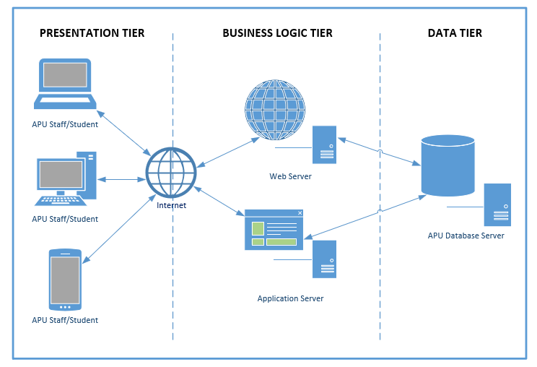

Figure 29 APU Three-tier Architecture

The data tier consists of APU database servers and the data access layer providing API, which is responsible for communication with the business logic tier. It is the place to store the data and identify the organizational data structure. The business logic tier acting as a connection between the presentation tier and data tier, manages APSpace’s functionalities by implementing a series of business rules. It is the heart of the entire system and can retrieve and modify data from the data tier. The application tier describes the user interface of APSpace that clients are able to interact with it. It is in charge of collecting input from the clients and presenting the data provided by the business logic tier. The presentation tier of APSpace delivers its services via web server technology. With the Internet, the browser will communicate with the web server through HTTP protocol and display the APSpace user interface to the clients. Then, the web server will wait for the HTTP request and response. After that, when receiving a new request, the web server will communicate with APU database servers using SQL queries. In the three-tier architecture, the data tier and presentation tier are not able to communicate with each other directly.

With the web server technique, the users are not required to install APSpace on every device, which results in wasting resources. Instead, they just need to access the APSpace through a web browser. The developer can maintain and modify each tier of three-tier architecture individually without affecting other tiers. For example, the new design of the APSpace user interface will not affect the APU database.

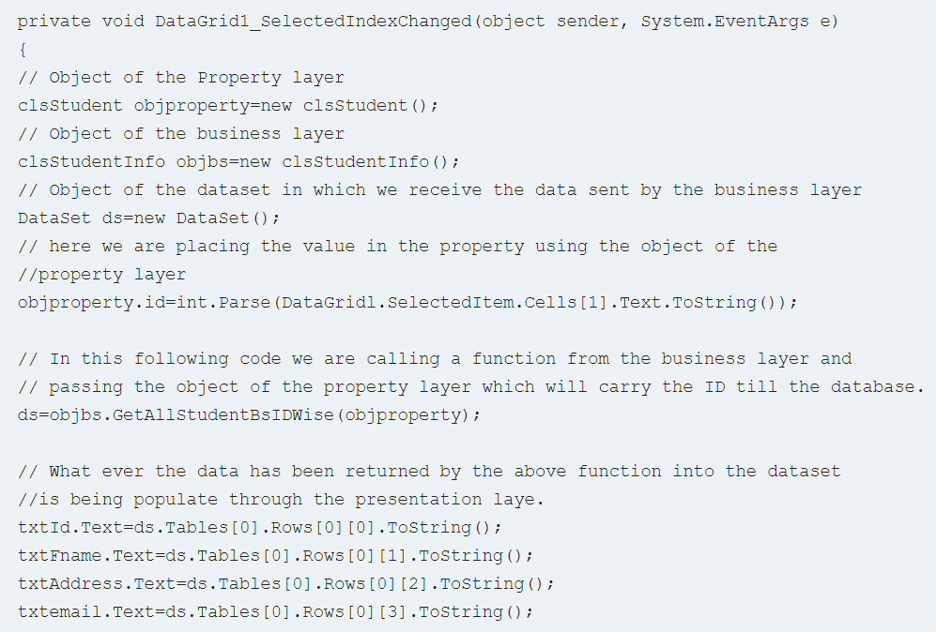

Figure 30 Presentation Tier Code Snippet (Martin, 2022)

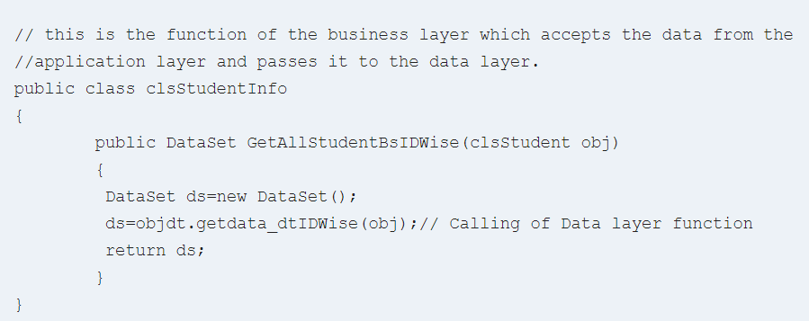

Figure 31 Business Logic Tier Code Snippet (Martin, 2022)

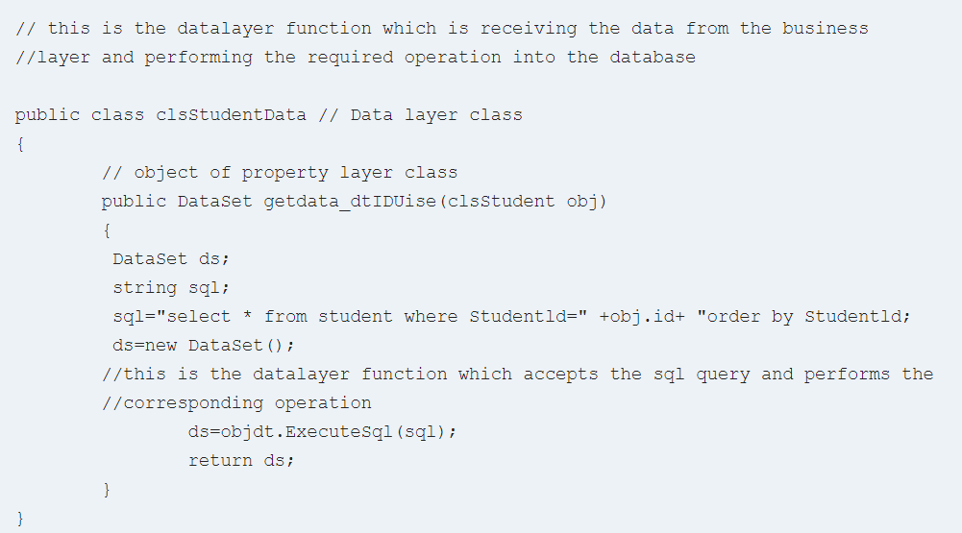

Figure 32 Data Tier Code Snippet (Martin, 2022)

# Part 2

## Design of Web Components

### Java Server Pages (JSP)

Java Server Pages (JSP) is a technique implemented on the server side to create web applications or dynamic web contents. JSP can access all Java APIs, including Java Database Connectivity (JDBC), for accessing enterprise databases. It usually works with Servlet technology. The most significant difference between JSP and Servlet is that the developer can script Java code with Servlets and then embed client-side markup, such as HTML, into Java code, while JSP allows the developer to start with client-side markup and then embed JSP tags to integrate the designed web pages with Java backend (Bhatia, 2018; Tyson, 2019).

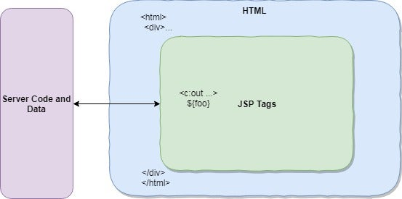

Figure 33 Interaction between Web Application Server, HTML, and JSP (Tyson, 2019)

From the diagram above, a JSP page is made up of HTML markup that is embedded with JSP tags. HTML is represented as a webpage, an application view from the client side when the file is processed on the server. JSP enables the interleaving of Java code and predefined actions with HTML, leading to the pages being compiled and executed on the server to convey the data. Instead of machine code, Java bytecode is used in the compiled pages and any dependent Java libraries. Similar to other Java programs, they are needed to be performed within a Java Virtual Machine (JVM), which provides a runtime environment for Java code. JSP is typically applied to deliver HTML and XML files. However, utilizing OutputStream can also assist JSP in delivering other types of data (Tyson, 2019).

With JSP, Java code does not have to be self-contained within a single scriptlet block. It can cross-markup content as long as the page as a whole is syntactically correct. For example, a compilation of pages will be successful only if the Java if/for/while blocks opened in one scriptlet is closed correctly. Contents within the split block of Java code will depend on that code. Similarly, the content within an “if” block will be triggered only if the “if” condition changes to True (“JavaServer Pages,” 2012).

Implementing the JSP technique does not require the developer to know advanced Java knowledge. It is beginner-friendly and easy to apply to a project. Besides, JSP is able to deal with handling exceptions and reduce the lengthy code as it enables action tags, custom tags, and others. Through utilizing JSP, the connection between Java code and the database becomes easier (Bhatia, 2018).

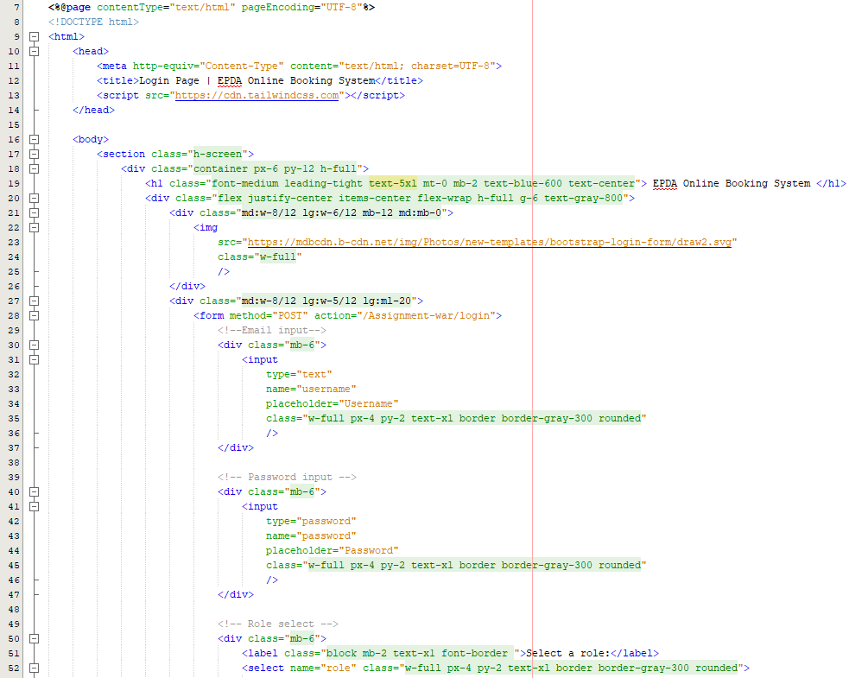

Figure 34 JSP used for Login Page (Part1)

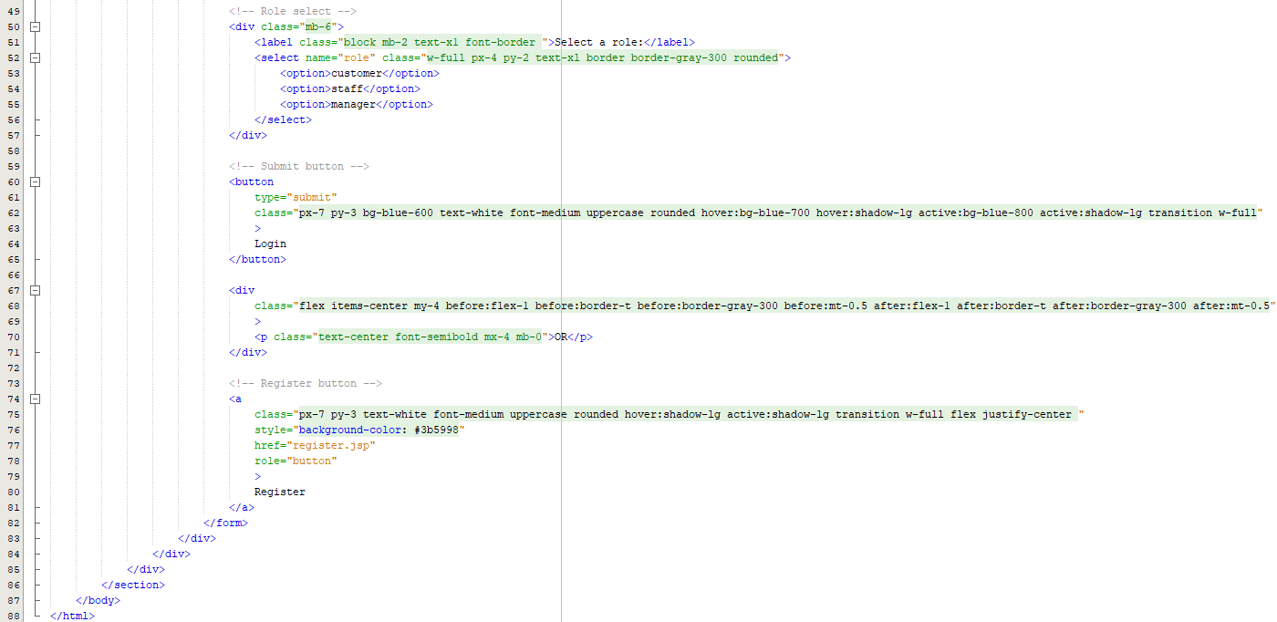

Figure 35 JSP used for Login Page (Part2)

The two diagrams above show the JSP technique used in the developed system, EPDA Online Booking System. JSP is implemented in the presentation layer and used to design the webpage. Through the login webpage URL, the users can view and interact with the page by typing the info in the text input and clicking the buttons which lead to login and register. By clicking the “Login” button, the input information will be sent to the Servlet and passed to the login function.

### Servlet

Servlet is also a Java program that runs on the Web as well as application servers. This technique is applied to process the request from Web servers, generate the responses, and send the responses back to the Web servers. Web applications can be built using Servlets without the performance limitation of Common Gateway Interface (CGI) programs since Servlets are component-based and platform-independent. Compared to CGI, Servlet is more portable and efficient as direct communication with Web servers is possible. Besides, Servlet is able to handle the cookies and is cheaper than CGI (Chauhan, 2021).

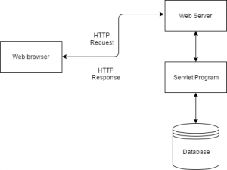

Figure 36 Servlet Architecture (Chauhan, 2021)

Servlet acts as an intermediary between Web Server and database. To display a web page, the web browser from the client-side will first send an HTTP request to the Web Server. After receiving the request, the Web Server will pass it to the respective Servlet. Then, Servlet will process the response with the help of the database, produce an output request, and send it back to the Web Server. Finally, the Web Server will send the HTTP response back to the web browser on the client-side and display the web page on the screen (Chauhan, 2021).

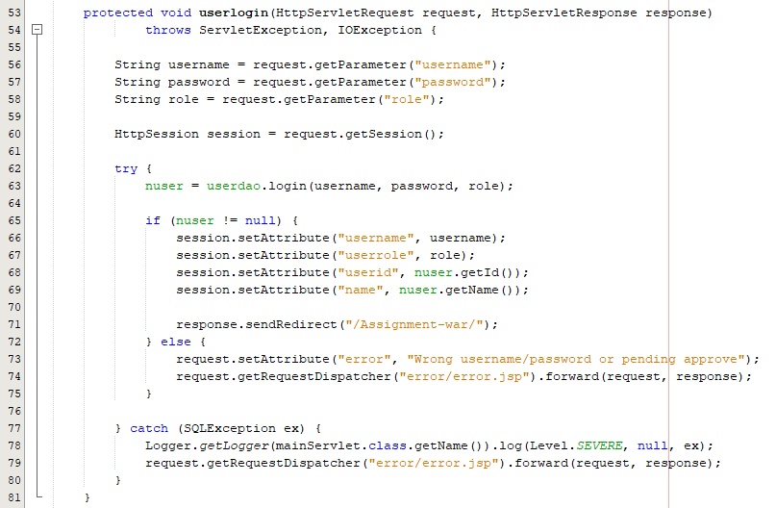

Figure 37 Servlet used for User Login

The diagram above shows the Servlet technique used for receiving the HTTP request from the client side and processing the business logic by accessing the database and invoking the Enterprise Java Beans (EJBs). After generating the output, it creates and forwards the response to another JSP page or Servlet.

## User Manual

### Webpage Design

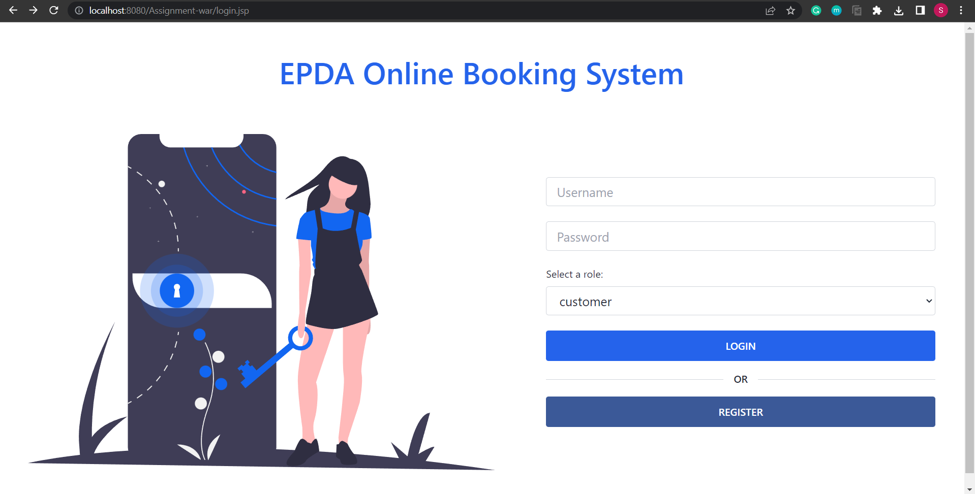

Figure 38 Login Page

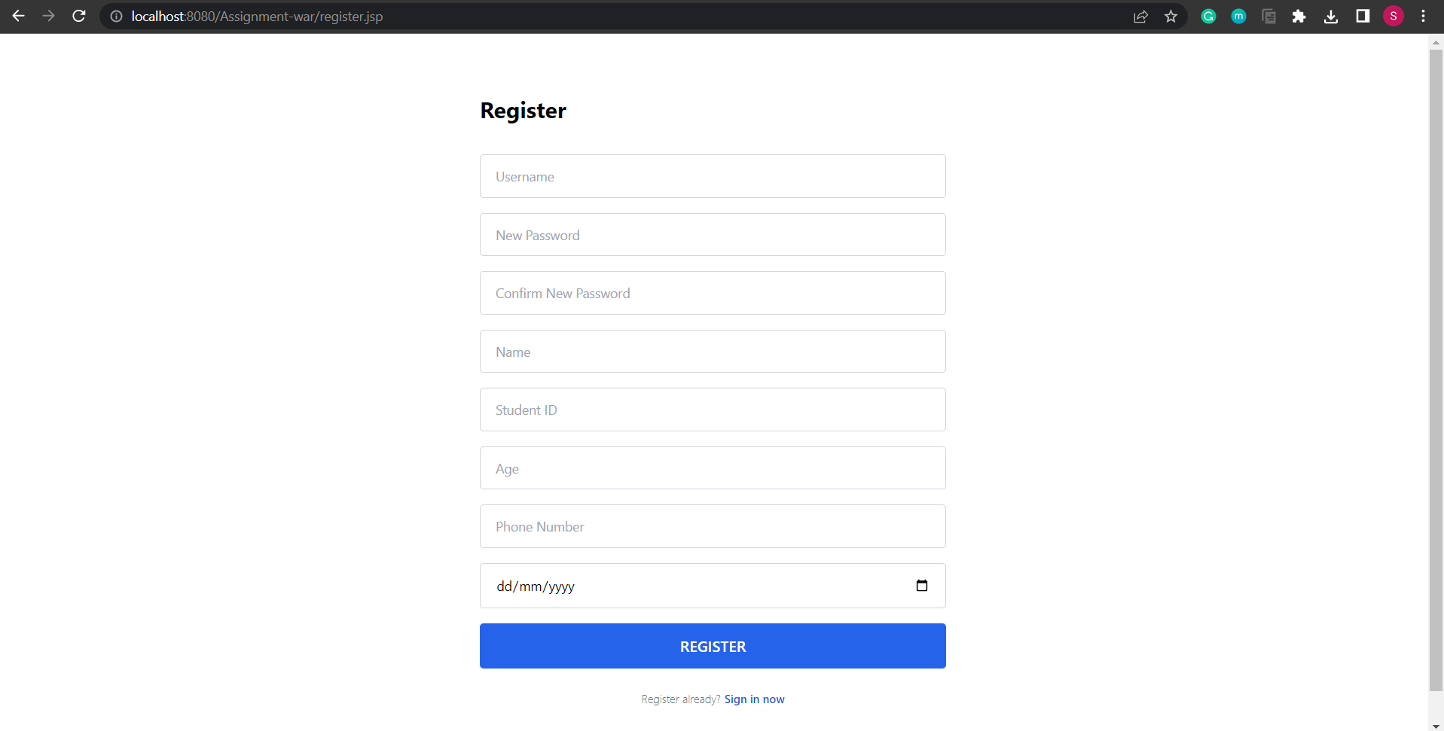

Figure 39 Register Page

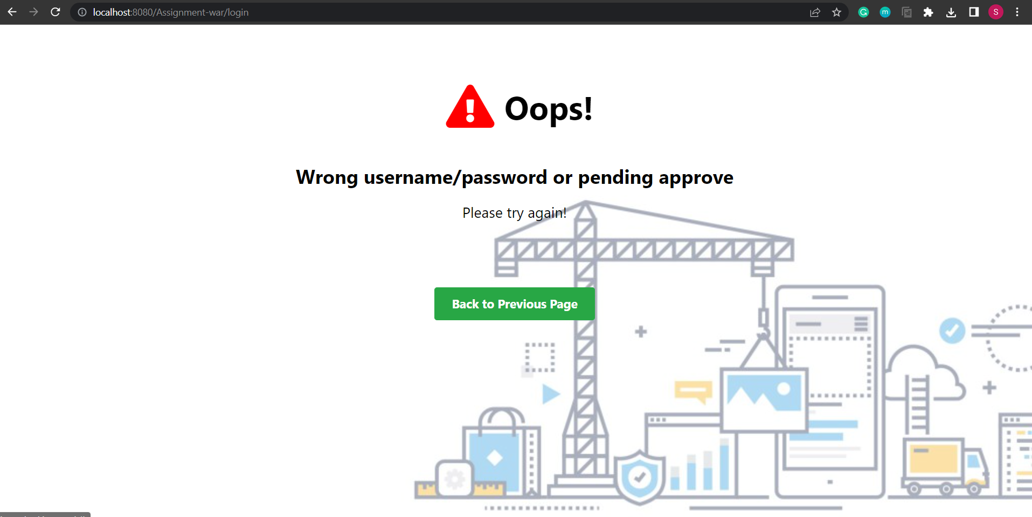

Figure 40 Error Page

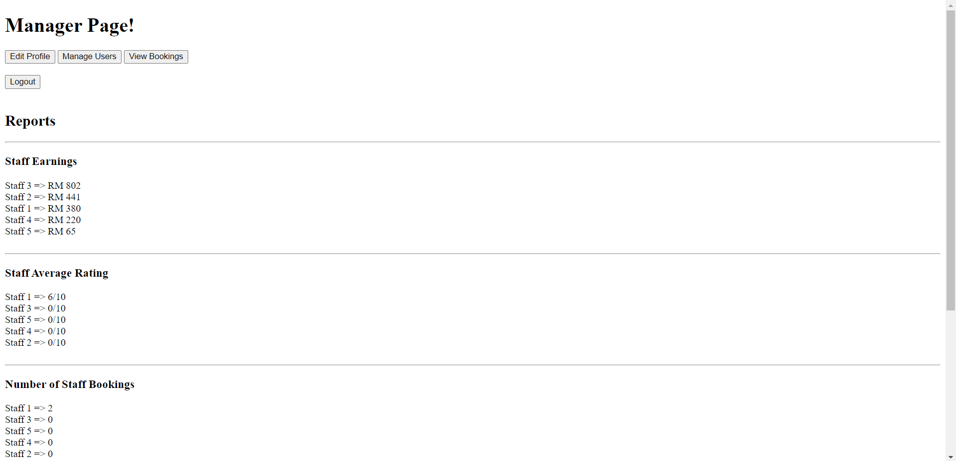

Figure 41 Manager Home Page

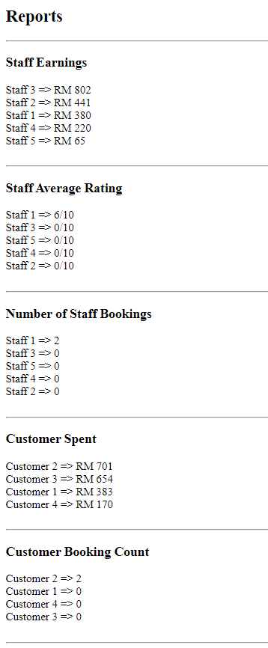

Figure 42 Reporting Functionality

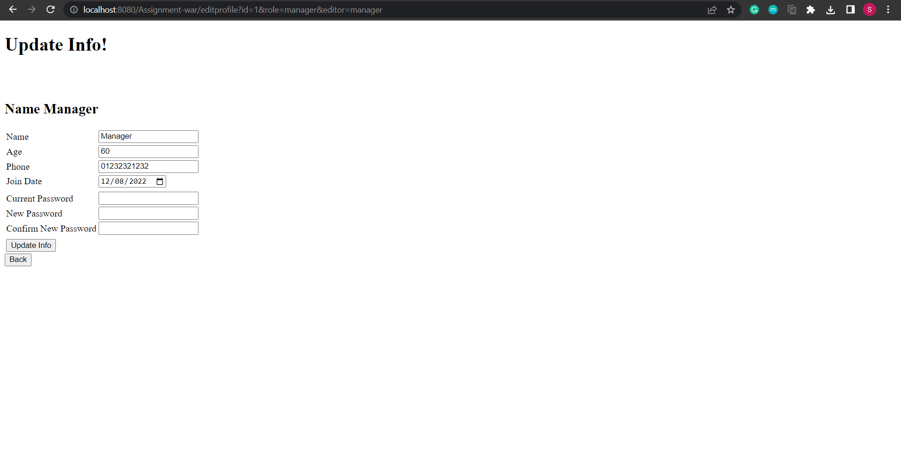

Figure 43 Edit Profile Page

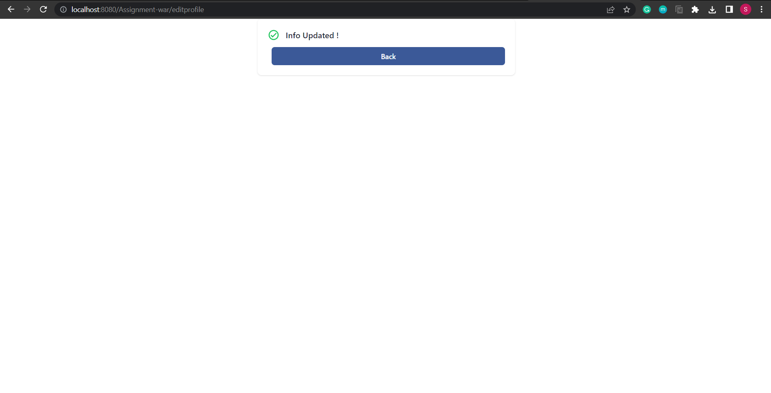

Figure 44 Success Notification Page

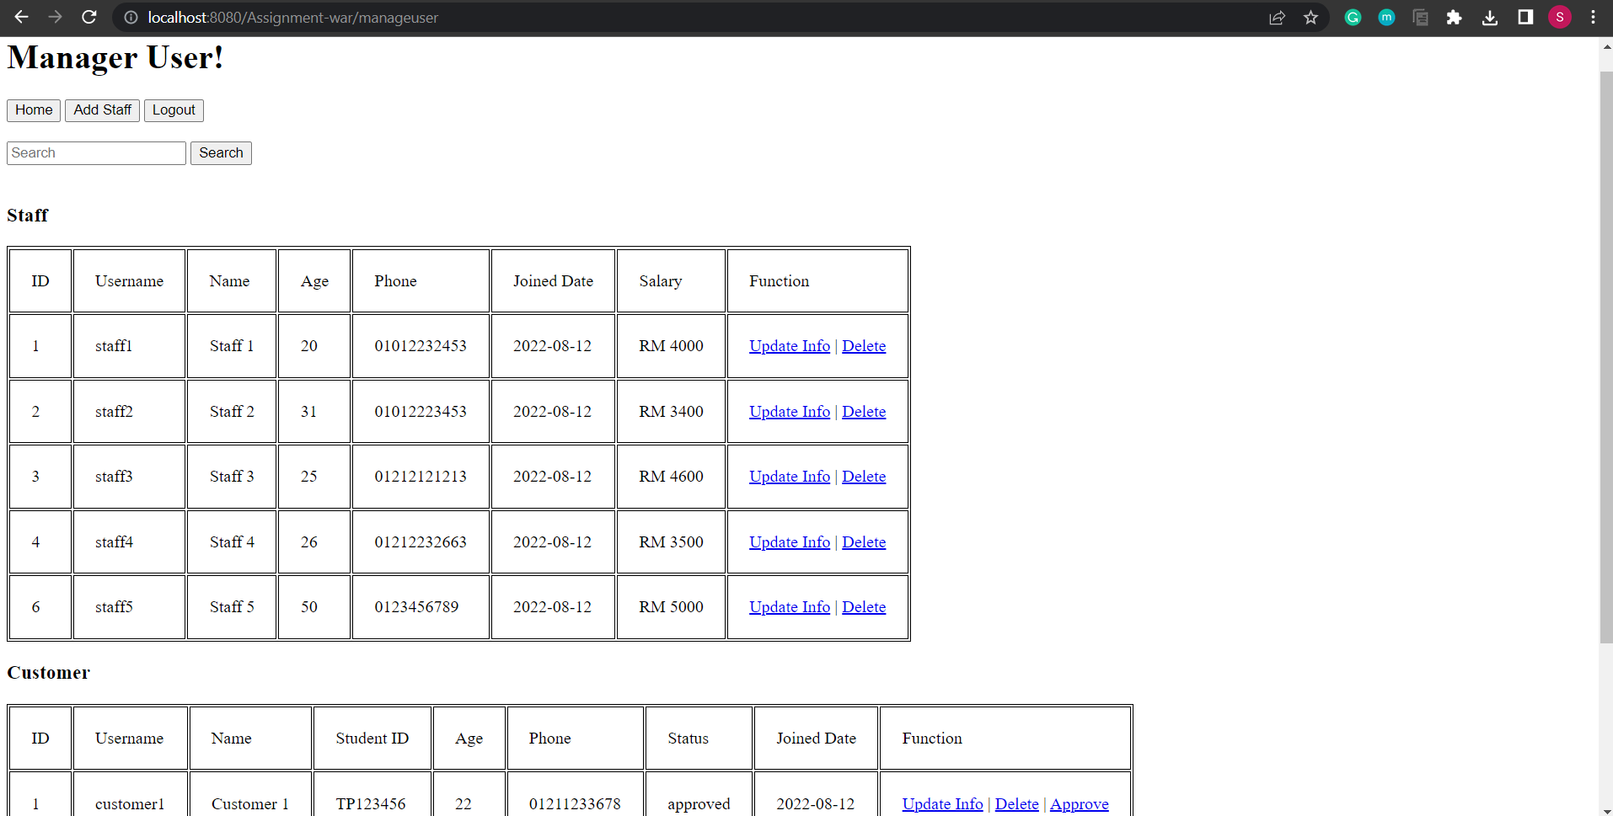

Figure 45 Manage Staff and Customer Page

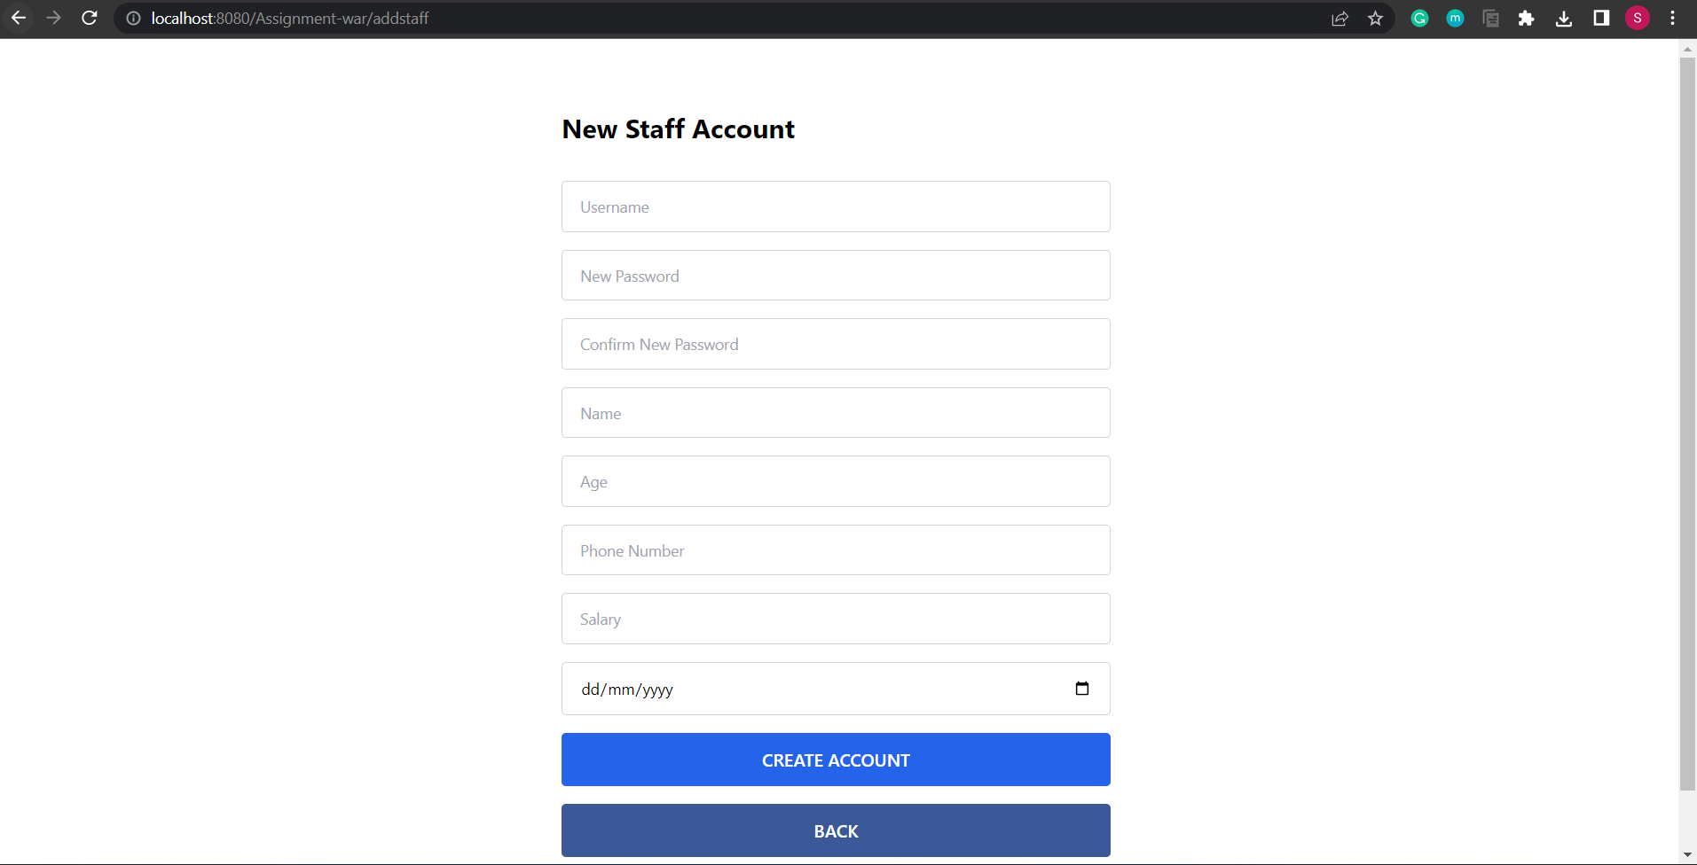

Figure 46 Add Staff Page

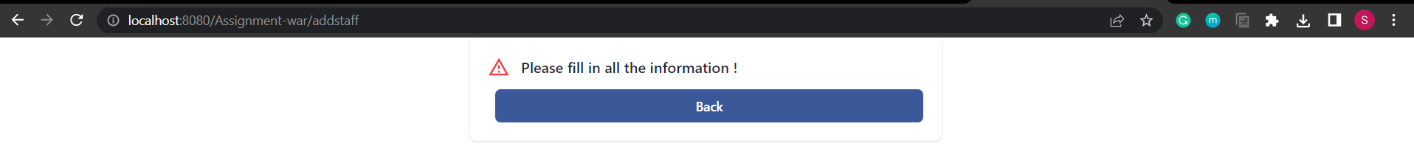

Figure 47 Fail Notification Page

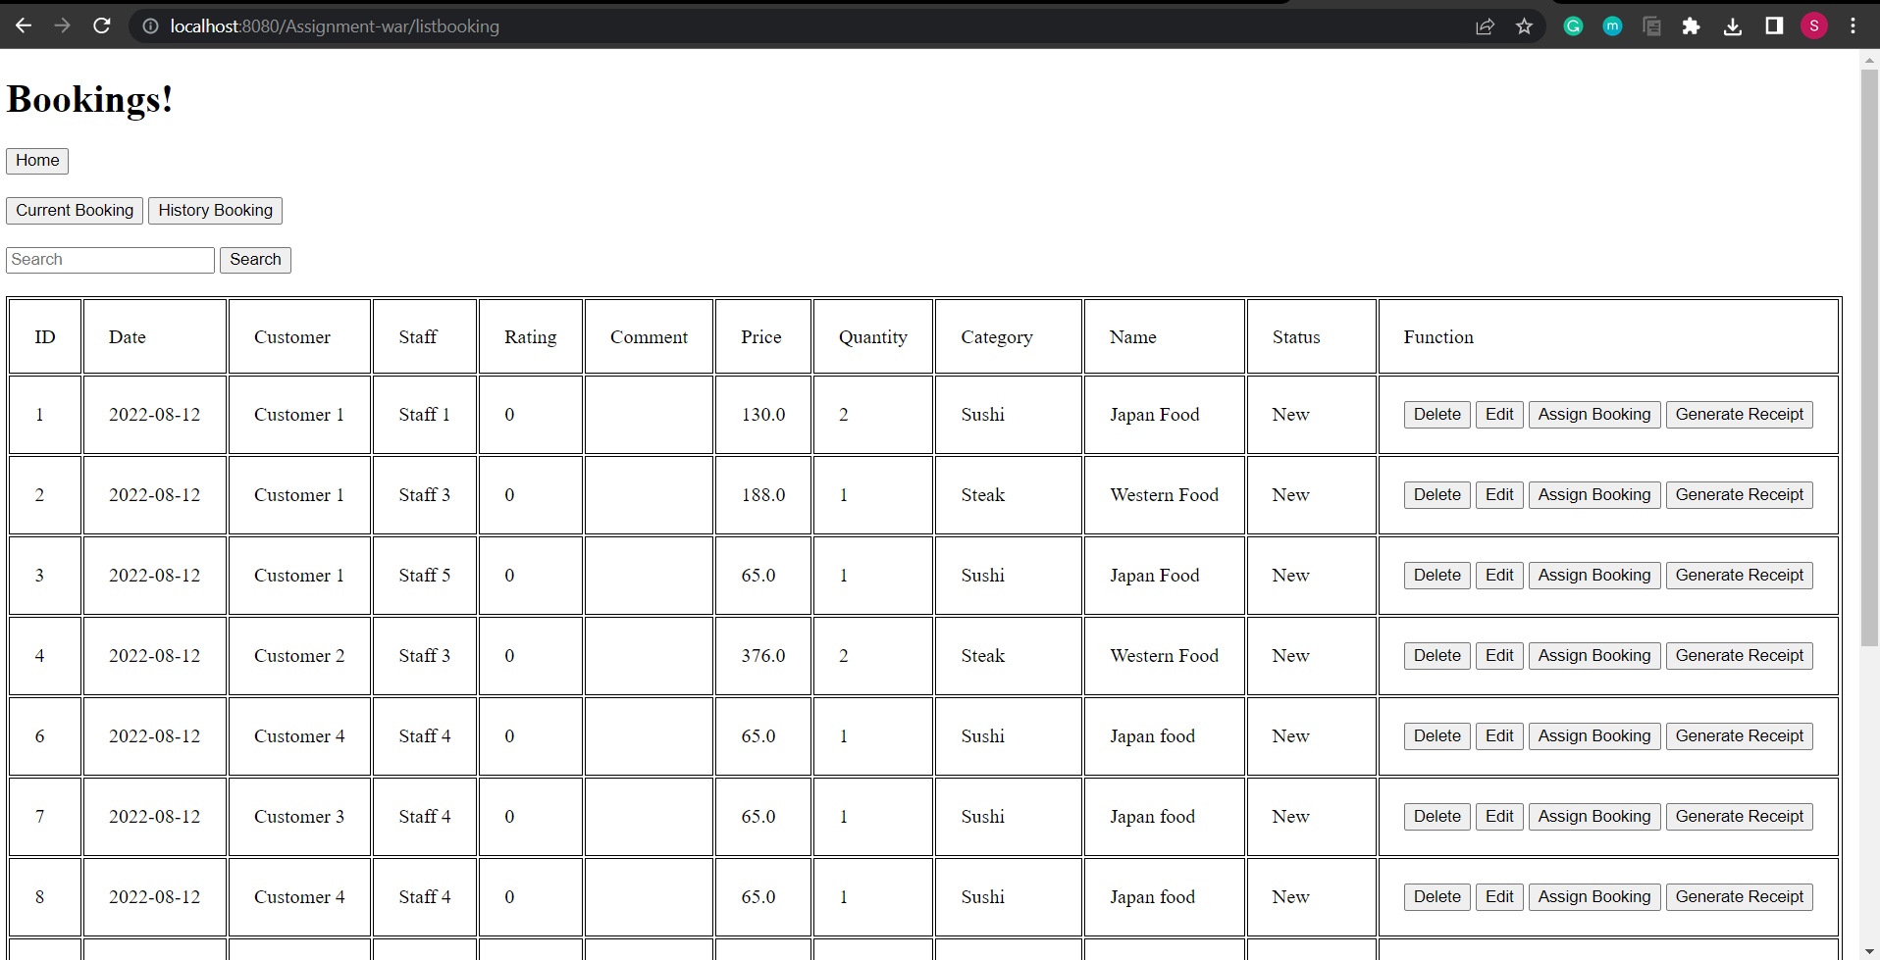

Figure 48 Manage Booking Page

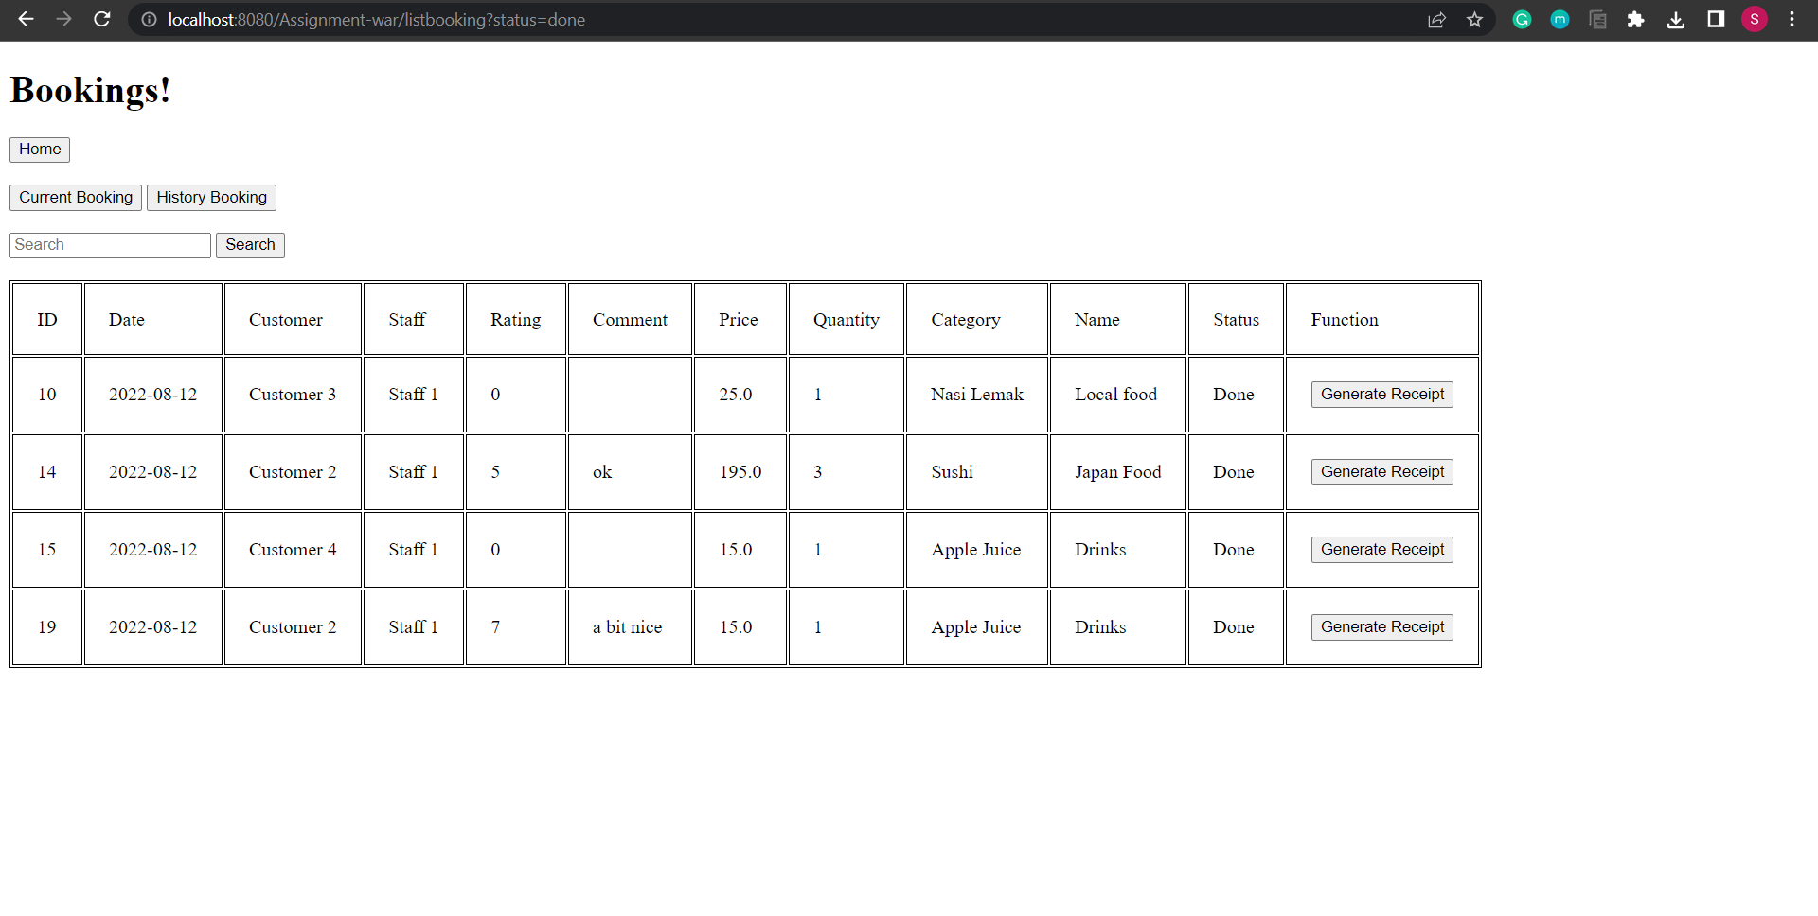

Figure 49 History Booking Page

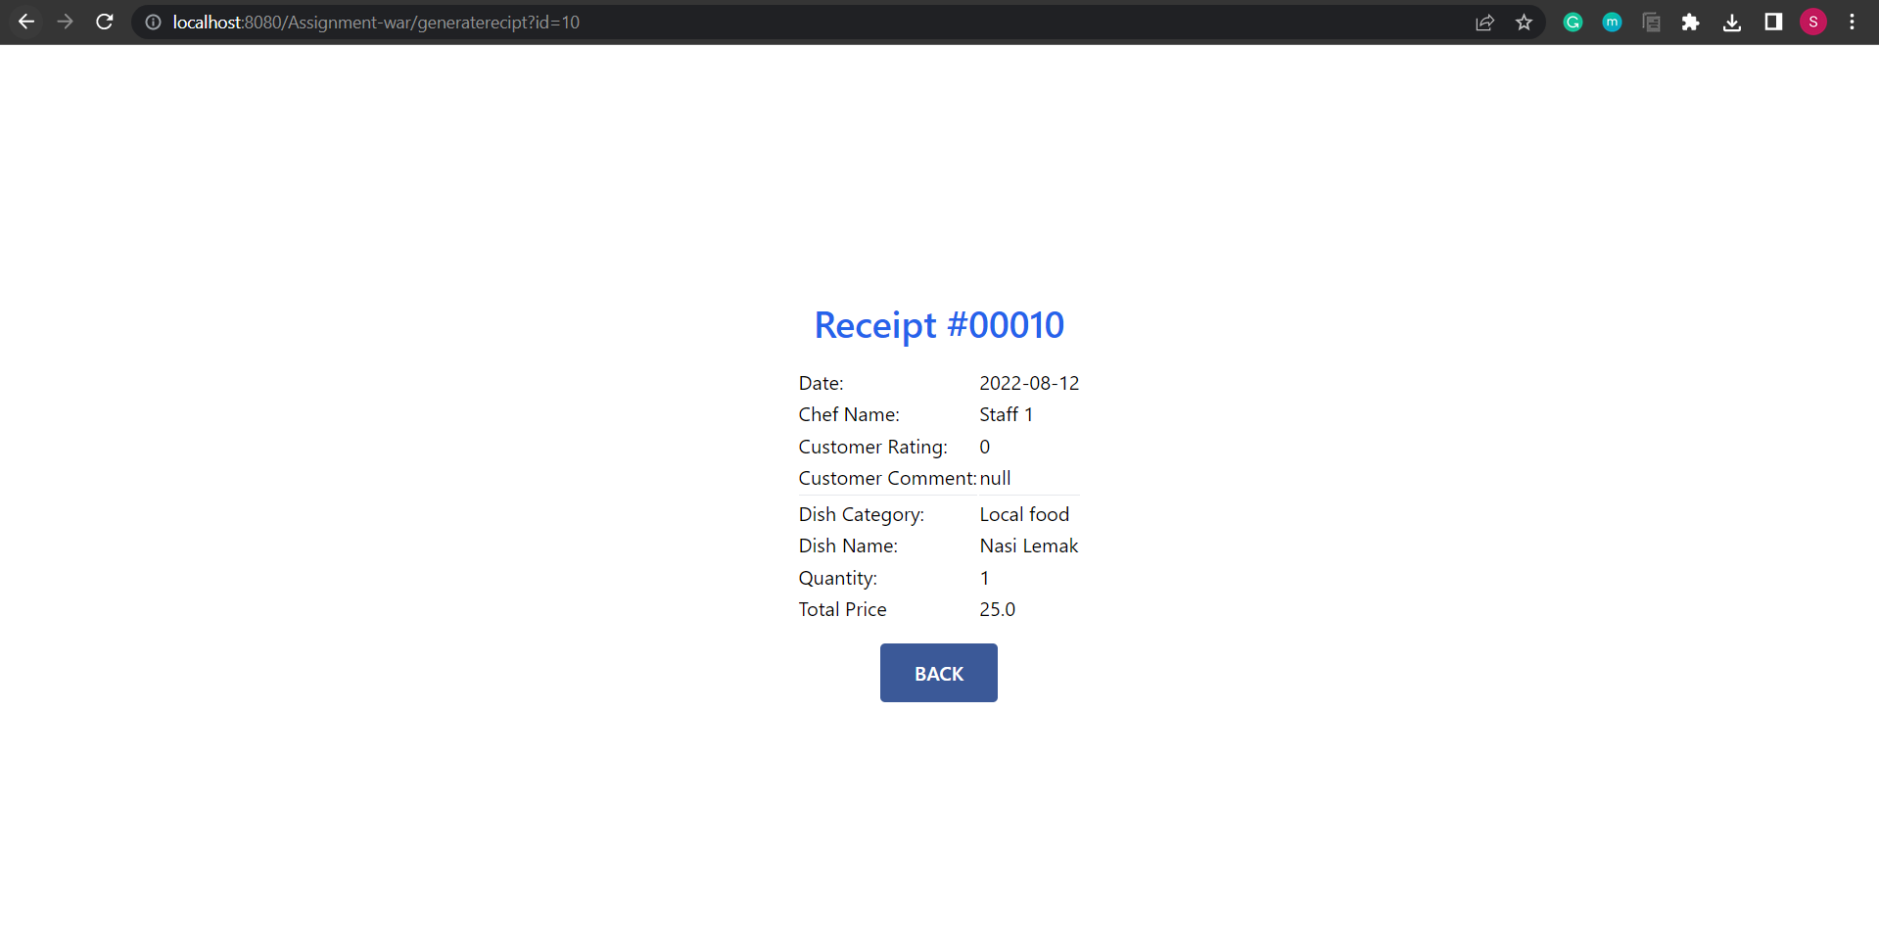

Figure 50 Receipt Page

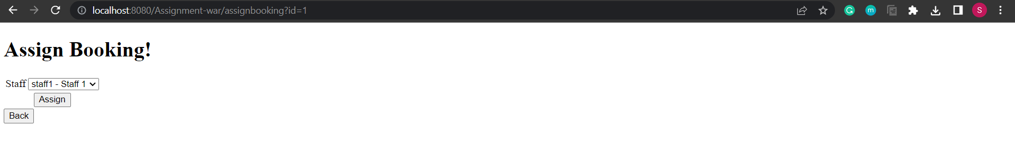

Figure 51 Assign Booking Page

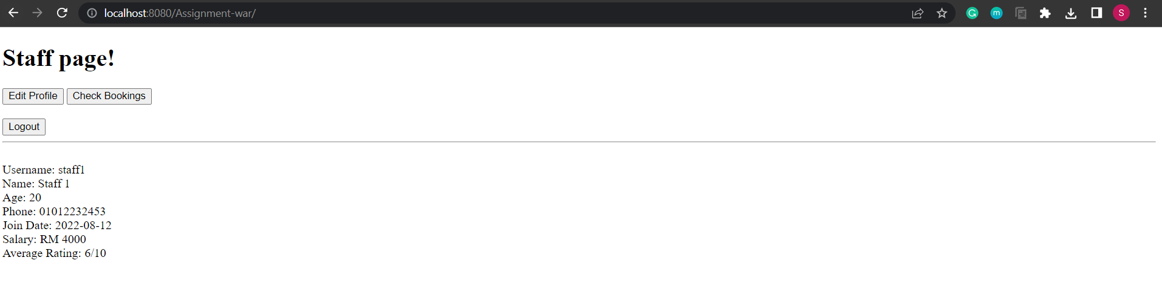

Figure 52 Staff Home Page

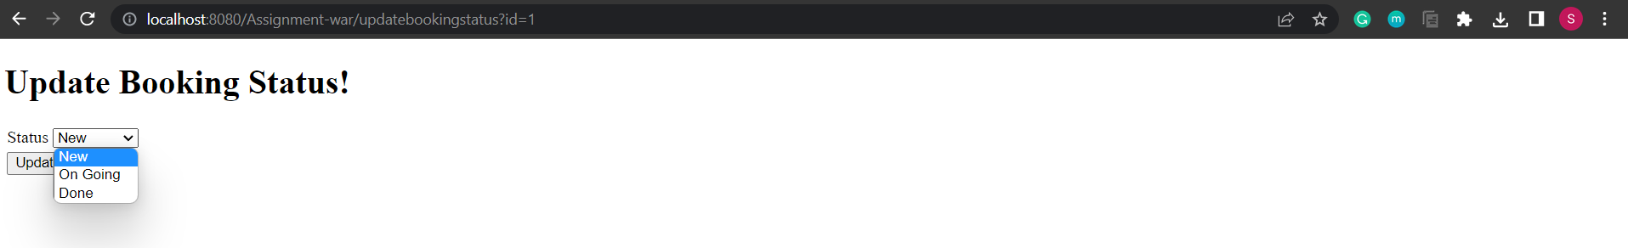

Figure 53 Update Booking Status Page

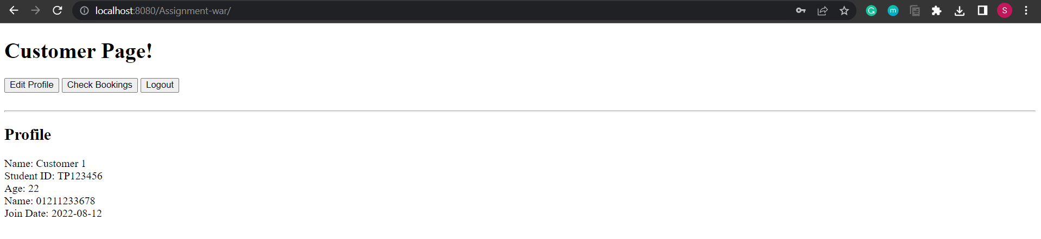

Figure 54 Customer Home Page

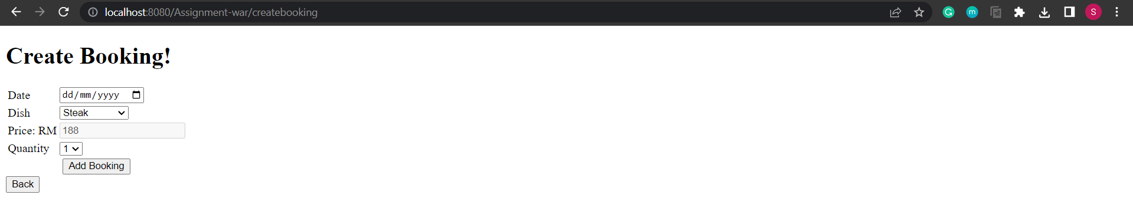

Figure 55 Create Booking Page

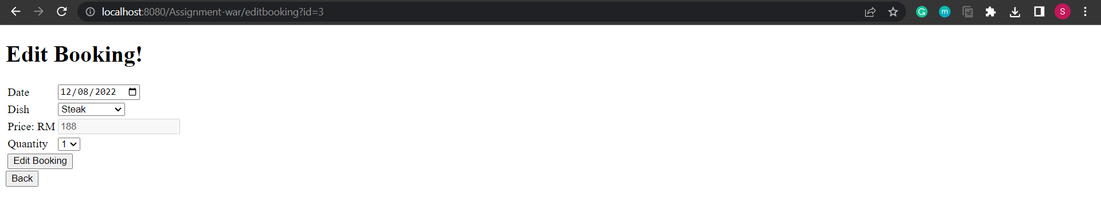

Figure 56 Edit Booking Page

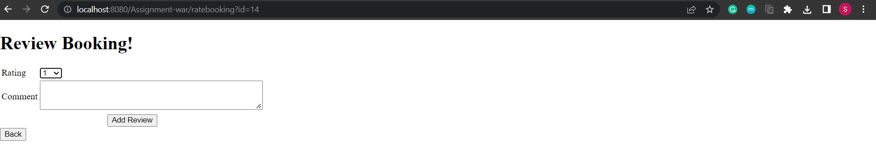

Figure 57 Rating Page

### Site Map & Navigation Chart

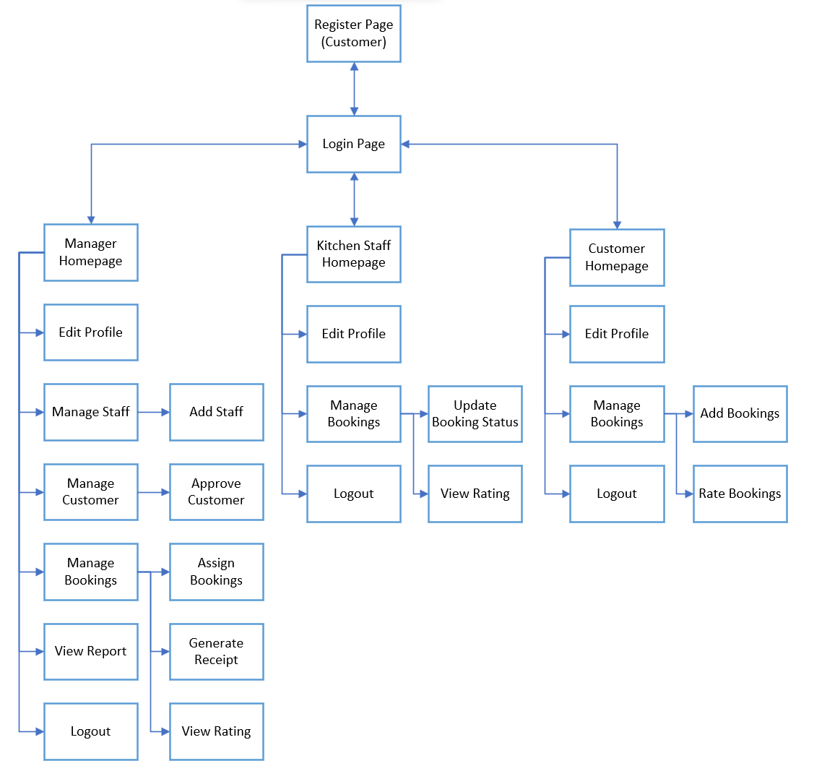

Figure 58 Site Map

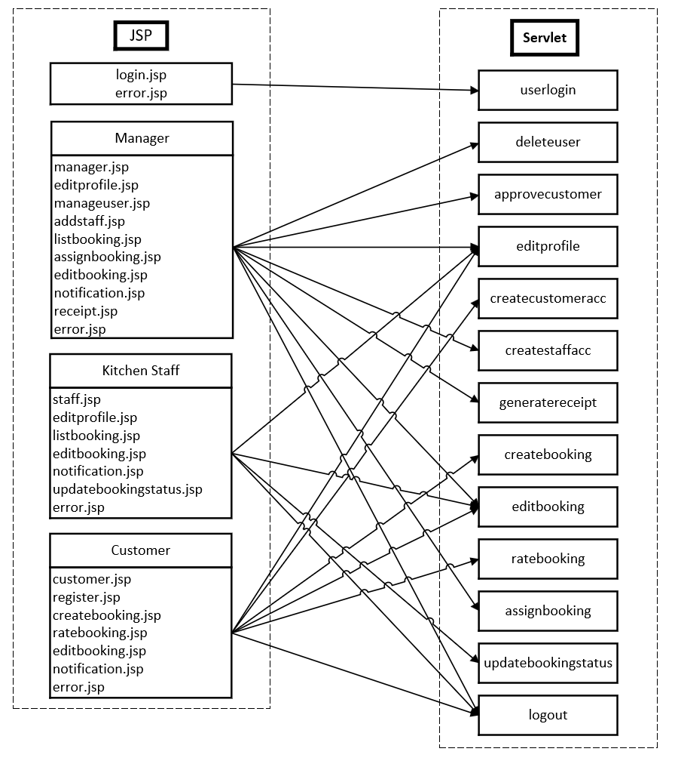

Figure 59 Navigation Chart

# Part 3

## Overview of Web Application

The developed web application is an APU Cafeteria Online Booking System designed to enable APU students to order food and drinks remotely. This developed system has three types of users: managers, kitchen staff, and customers. All the users must provide the correct username and password for authentication and authorization purposes before accessing the system functionalities. A detailed feature description for each user type is provided as follows:

**Manager**

* To manage staff information, including the ability of adding, deleting, searching, and updating.
* To manage customer information, including the ability of approving, deleting, searching, and updating.
* To assign the newly created bookings to kitchen staff.
* To view ratings and comments provided by customers.
* To generate receipts for each booking.
* To view the summary reports, including staff earnings, average staff rating, number of staff bookings, the customer spent amount, and total customer bookings.
* To edit the manager’s profile.

**Kitchen Staff**

* To edit the staff’s own profile.
* To view the bookings assigned to them.
* To update booking status (new, on going, done).
* To view ratings and comments provided by customers according to the assigned bookings.

**Customer**

* To register as a customer and wait for the manager to approve.
* To edit the customer’s own profile.
* To add new booking.
* To manage their own bookings, including the ability of deleting, searching, and updating.
* To rate and comment the bookings stated as “done.”

The developed online booking system is using multi-tier architecture transmitting data between layers. A detailed description of each tier and their interconnection is given below:

* **Presentation Tier**: Describe the user interface of the system that users are able to interact with it. It is in charge of collecting input from the clients and presenting the data provided by the business logic tier via a web server. JSP and Servlet techniques were implemented in the presentation tier.
* **Business Tier:** Acts as a connection between the presentation tier and database tier and manages the online booking system’s functionalities by implementing a series of business rules. It is the heart of the entire system and can retrieve and modify data from the data tier. Enterprise Java Beans (EJBs) are used for connecting the business logic and processes to the backend database via Java Database Connectivity (JDBC).
* **Database Tier**: Consists of MySQL database servers and the data access layer providing API, which is responsible for communication with the business logic tier. It is the place to store the data and identify the organizational data structure.

## Design of Business Tier

Enterprise Java Beans (EJBs) are server-side software which aids in summarizing an application’s business logic. It is able to assist developers in creating reliable and secure web applications. EJB enumeration is a part of Java Enterprise Edition enumeration. EJB managers will manage the issues such as transnational property, security, and endurance, allowing developers to concentrate more on the relevant areas of the enterprise applications (Anamika Kalwan, 2019).

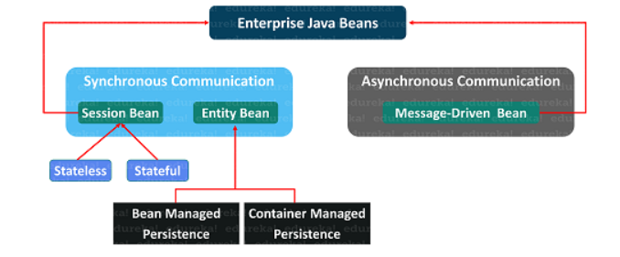

Figure 60 Enterprise JavaBeans (Anamika Kalwan, 2019)

An application server like GlassFish is needed to run an EJB application. There are three types of EJBs: Session Bean, Entity Bean, and Message-Driven Bean. An entity bean represents the business objects stored in a persistent storage mechanism at the end of a session. Examples of business objects include the username, book name, and food price. A relational database serves as a persistent storage method in J2EE. Every entity bean in a relational database has its own table, and each bean instance corresponds to a specific table row (Anamika Kalwan, 2019).

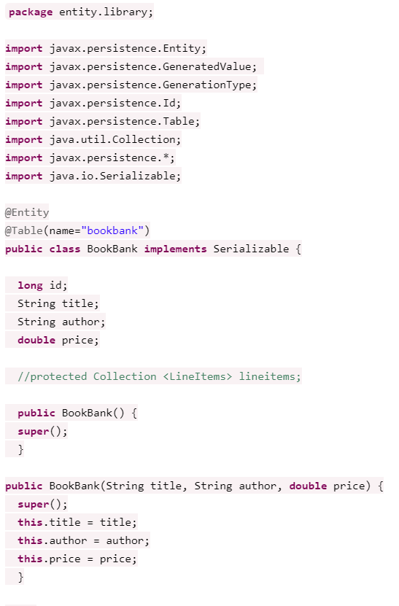

Figure 61 Entity Beans Code Example

On the other hand, session beans are non-persistent enterprise beans. The application server (EJB container) maintains the session beans life cycle. It can be implemented for accessing the database, performing calculations, and others (Anamika Kalwan, 2019).

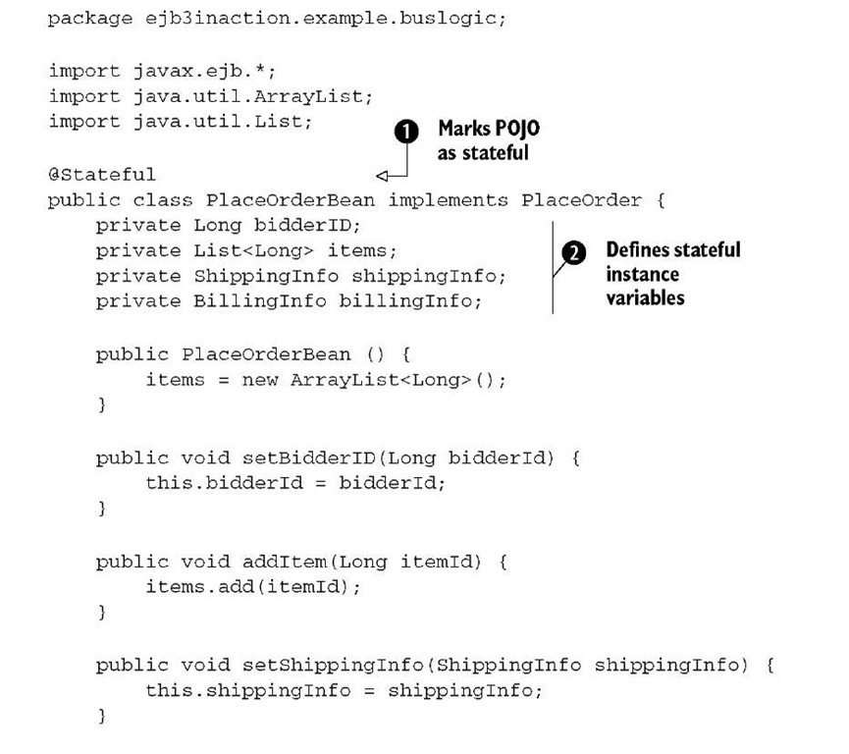

Figure 62 Session Beans Code Example

## UML Diagrams

### Use Case Diagram

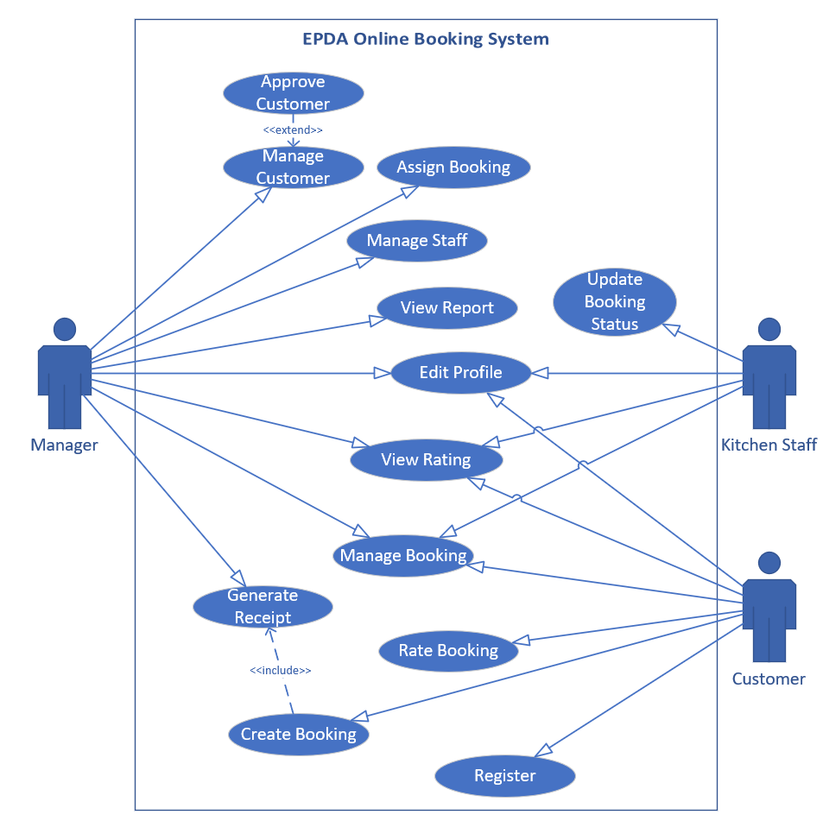

Figure 63 Use Case Diagram

### Class Diagram

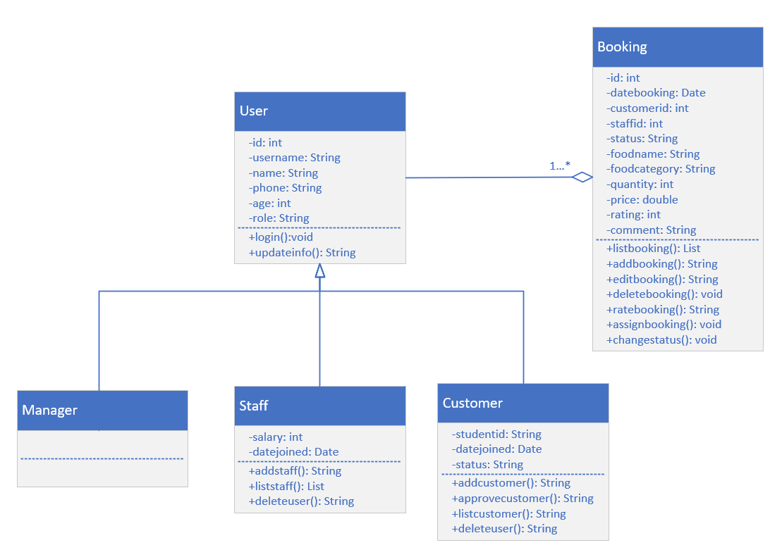

Figure 64 Class Diagram

# Part 4

## Database Design

In this project, the developer utilized a MySQL database management system to store the data of bookings and three types of users, which are managers, kitchen staff, and customers. In addition, XAMPP Control Panel was implemented to connect the NetBeans and MySQL via Port 3306.

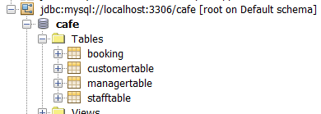

Figure 65 Entities in Database

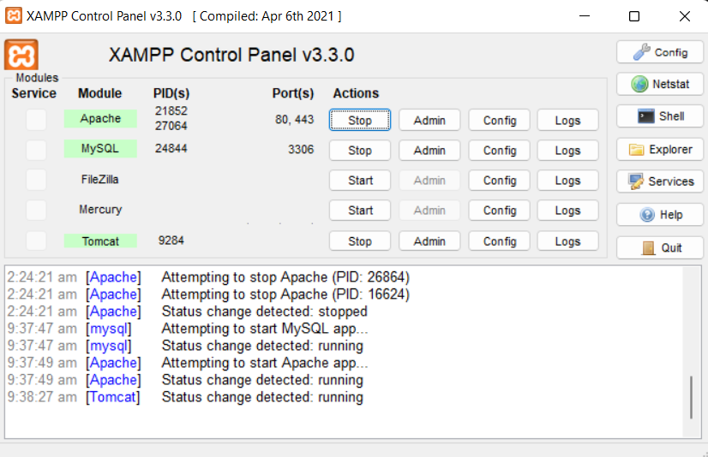

Figure 66 XAMPP Control Panel

Besides, the developer also wrote an SQL script for creating databases and inserting the predefined attributes into the created databases. The example of SQL scripting is shown as follows:

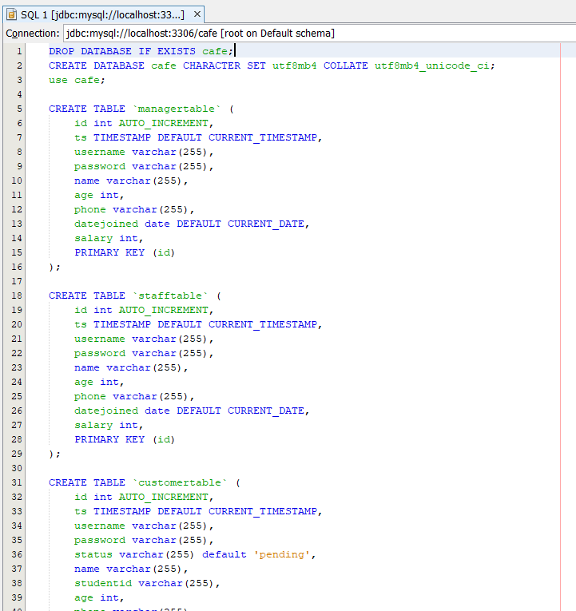

Figure 67 SQL Query for Initializing Database

**Manager Database & Kitchen Staff Database**

The information of the manager and kitchen staff are stored in different databases, but they have the same attributes, which are described as follows:

|  |  |  |  |  |  |  |  |
| --- | --- | --- | --- | --- | --- | --- | --- |
| **ID** | **USERNAME** | **PASSWORD** | **NAME** | **AGE** | **PHONE** | **DATEJOINED** | **SALARY** |
| int | String | String | String | int | String | Date | int |

* id: Manager/Staff’s Identification
* username: Manager/Staff’s Login Username
* password: Manager/Staff’s Login Password
* name: Manager/Staff’s Name
* age: Manager/Staff’s Age
* phone: Manager/Staff’s Phone Number
* datejoined: The Date of Manager/Staff Joined the System
* salary: Manager/Staff’s Monthly Salary

**Customer Database**

|  |  |  |  |  |  |  |  |  |
| --- | --- | --- | --- | --- | --- | --- | --- | --- |
| **ID** | **USERNAME** | **PASSWORD** | **STATUS** | **NAME** | **AGE** | **STUDENTID** | **PHONE** | **DATEJOINED** |
| int | String | String | String | String | int | String | String | Date |

The attributes of the customer database are described as follows:

* id: Customer’s Identification
* username: Customer’s Login Username
* password: Customer’s Login Password
* status: Customer’s Account Status (Pending/Approved)
* name: Customer’s Name
* age: Customer’s Age
* studentid: Customer’s Student Identification
* phone: Customer’s Phone Number
* datejoined: The Date of Customer Joined the System

**Booking Database**

|  |  |  |  |  |  |  |
| --- | --- | --- | --- | --- | --- | --- |
| **ID** | **CUSTOMERID** | **STAFFID** | **DATEBOOKING** | **STATUS** | **FOODNAME** | **FOODCATEGORY** |
| int | int | int | Date | String | String | String |

The attributes of the booking database are described as follows:

|  |  |  |  |
| --- | --- | --- | --- |
| **QUANTITY** | **PRICE** | **RATING** | **COMMENT** |
| int | double | String | String |

* id: Booking’s Identification
* customerid: Customer’s Identification
* staffid: Kitchen Staff’s Identification
* datebooking: The Date of Customer Joined the System
* status: Booking’s Status (New/On Going/Done)
* foodname: Ordered Food Name
* foodcategory: Ordered Food Category
* quantity: Total Ordered Food Quantity
* price: Total Ordered Food Price
* rating: Customer’s Rating
* comment: Customer’s Comment

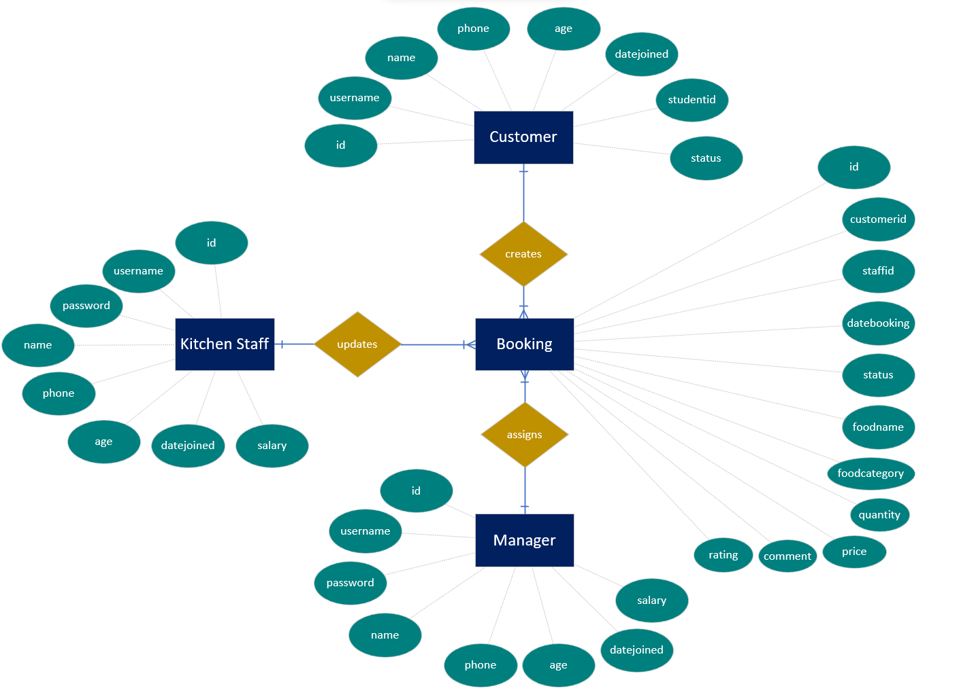

Figure 68 Entity Relationship Diagram (ERD)

# Part 5

## Additional Features

### CSS

The developer implemented the Cascading Style Sheets (CSS) to design the web pages. CSS makes the styling easier and enables customization for unleashing creativity. Most of the attractive style of a web page is handled by CSS. It allows the developer to select the text colour, font style, spacing between paragraphs, size and arrangements of columns, background colours or pictures, layout designs, differences in display for various device’s screen sizes, and others.

In this project, TailwindCSS was utilized as a framework to design the enterprise application. TailwindCSS is utility-first and highly customizable that does not enforce design guidelines or dictate how a website should look. Instead, the developer needs to combine little parts of CSS code to create a one-of-a-kind user interface.

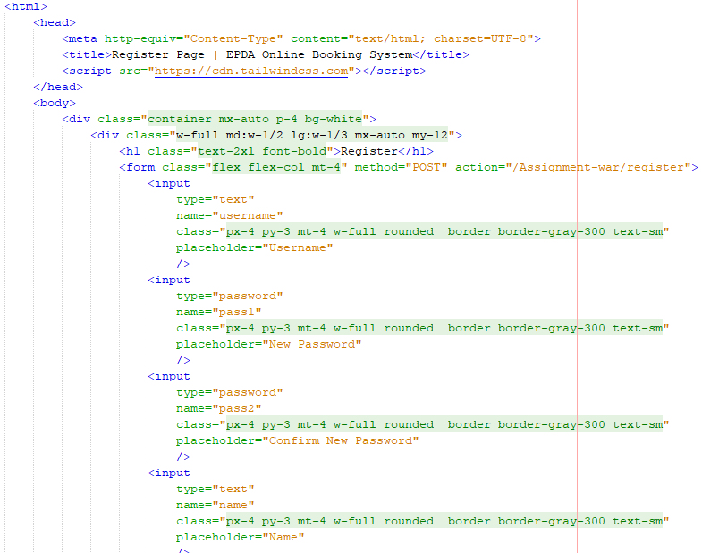

Figure 69 Tailwind CSS Code Example

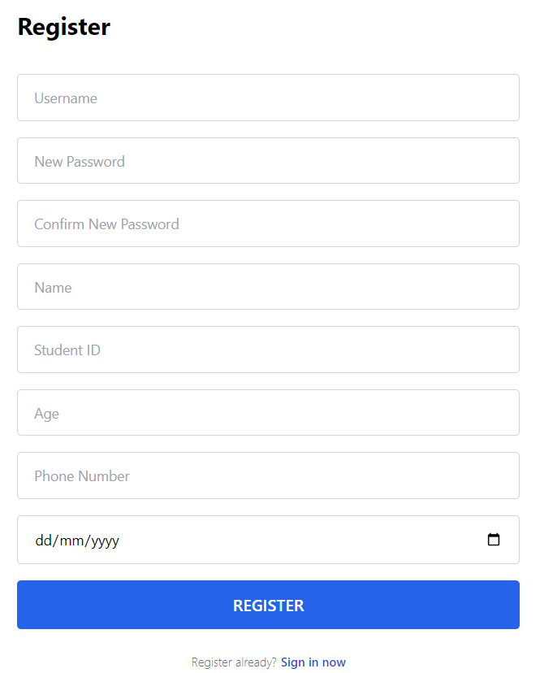

Figure 70 Register Page Designed using Tailwind CSS

Besides, Bootstrap, an open-source CSS framework, was also implemented to design the Error Page, which is shown below:

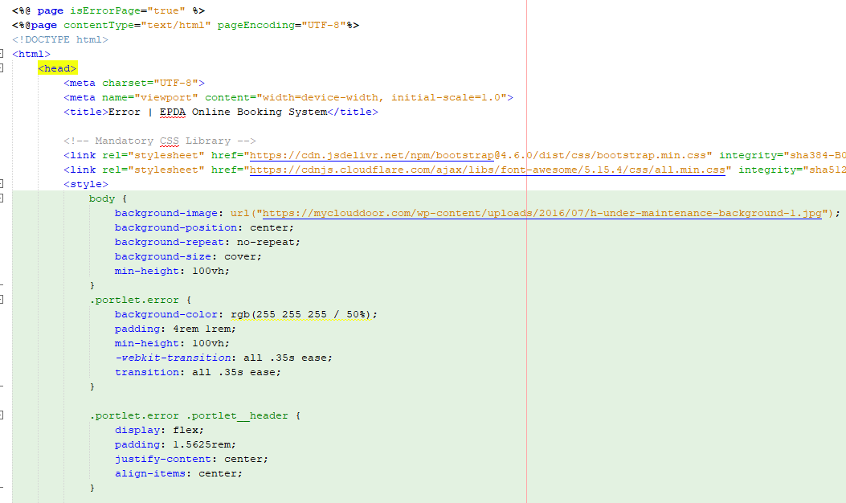

Figure 71 Bootstrap Code Example

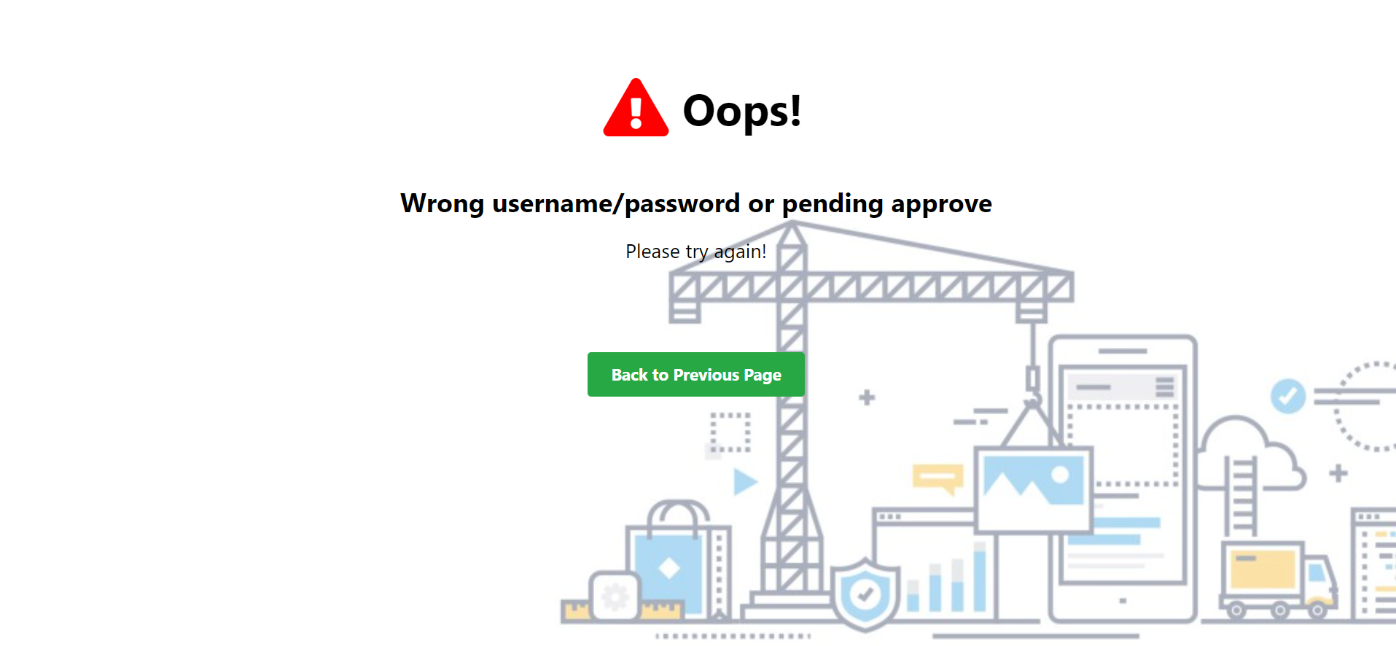

Figure 72 Error Page Designed using Bootstrap

### MySQL Database Management System

As mentioned in Part 4, the developer has utilized MySQL Database to store user and booking information. The username and password of the database were stored in web.xml and passed to the Servlet in order to connect to the MySQL database for retrieving and updating data to proceed with the business logic.

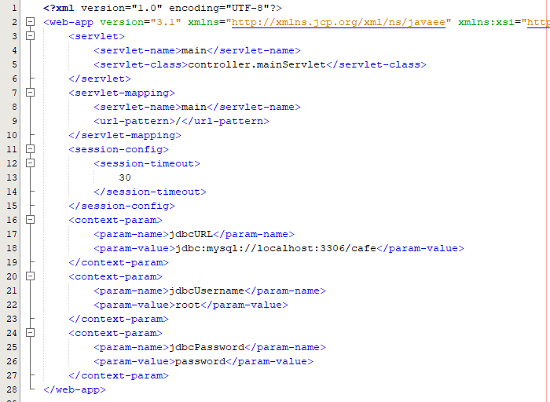

Figure 73 Database URL, Username, and Password Stored in web.xml

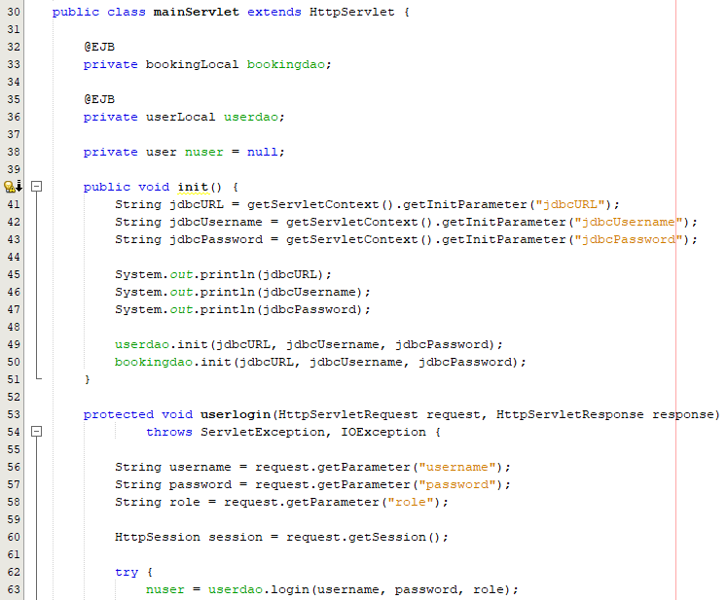

Figure 74 Passing Parameters to mainServlet.java

### Date Picker

Another additional feature included in this project is the date picker which is implemented on several web pages, including the register page, add staff page, create booking page, and edit booking page. This function is provided by the JSP technique by specifying the input as the “date” type. The user can simply click on any date, choose the month and year available in the calendar, and select the current date through the date picker functionality.

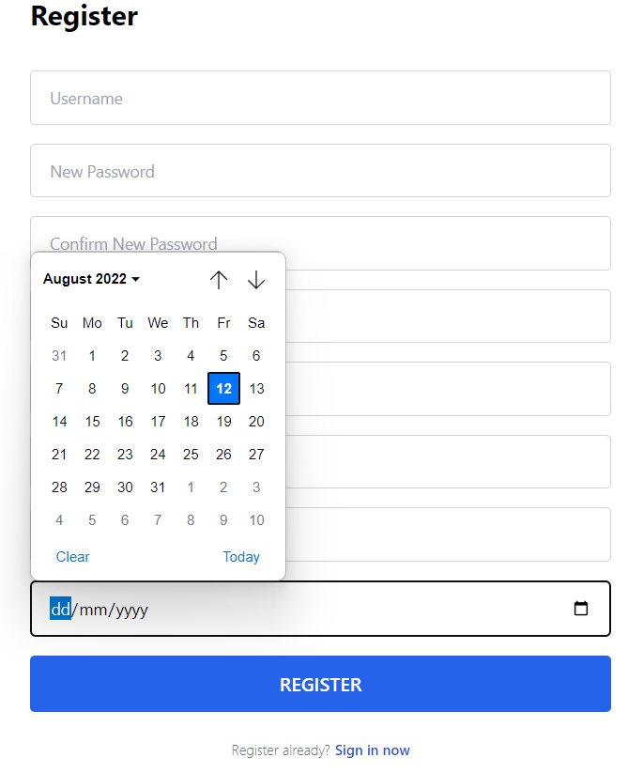

Figure 75 Date Picker in Register Page

# References

*A short history of the Web*. CERN. Retrieved 9 July 2022, from <https://home.cern/science/computing/birth-web/short-history-web>.

Abbate, J. (1999). *Inventing the Internet* (pp. 7-38). Braille Jymico Inc.

Ahn, N., Black, J., & Effrat, J. *History of Distributed Computing*. Cs.stanford.edu. Retrieved 8 July 2022, from <https://cs.stanford.edu/people/eroberts/courses/soco/projects/distributed-computing/html/body_history.html>.

Amini, M., & Abukari, A. (2020). ERP Systems Architecture for the Modern Age: A Review of the State of the Art Technologies. *Journal Of Applied Intelligent Systems and Information Sciences*, *1*(2), 70-90. <https://doi.org/10.22034/JAISIS.2020.232506.1009>

Anamika Kalwan. (2019).  *Java Certification Training Course*. Edureka. <https://www.edureka.co/blog/ejb-in-java/>

Anderson, S. (2022). *What Is Enterprise Resource Planning (ERP)?* Investopedia. Retrieved 9 July 2022, from <https://www.investopedia.com/terms/e/erp.asp#toc-benefits-of-enterprise-resource-planning-erp>.

Asia Pacific Univerisity. (2022). *Awards and Achievements | Asia Pacific University (APU)*. Apu.edu.my. Retrieved 10 July 2022, from <https://www.apu.edu.my/explore-apu/awards-achievements>.

Azure Architecture Center. *Event-driven architecture style*. Docs.microsoft.com. Retrieved 9 July 2022, from <https://docs.microsoft.com/en-us/azure/architecture/guide/architecture-styles/event-driven>.

Bhatia, V. (2018). *Introduction to JSP - GeeksforGeeks*. GeeksforGeeks. Retrieved 7 August 2022, from https://www.geeksforgeeks.org/introduction-to-jsp/.

Chauhan, A. (2021). *Introduction to Java Servlets - GeeksforGeeks*. GeeksforGeeks. Retrieved 7 August 2022, from https://www.geeksforgeeks.org/introduction-java-servlets/.

El-Sherif, H. (2014). Enterprise Resource Planning (ERP) Evaluation. <https://doi.org/10.13140/RG.2.2.30416.30720>

Fernando, C. (2018). *The evolution of Distributed Systems*. Medium. Retrieved 9 July 2022, from <https://medium.com/microservices-learning/the-evolution-of-distributed-systems-fec4d35beffd>.

Fernando, J. (2022). *What Is Supply Chain Management (SCM)?* Investopedia. Retrieved 9 July 2022, from <https://www.investopedia.com/terms/s/scm.asp>.

Foley, M. (2016). *Microsoft readies combined CRM, ERP Dynamics 365 cloud bundle*. ZDNet. Retrieved 10 July 2022, from <https://www.zdnet.com/article/microsoft-readies-combined-crm-erp-dynamics-365-cloud-bundle/>.

Grozev, N., & Buyya, R. (2013). Performance Modelling and Simulation of Three-Tier Applications in Cloud and Multi-Cloud Environments. *The Computer Journal*, *58*(1), 1-22. <https://doi.org/10.1093/comjnl/bxt107>

Hargrave, M. (2020). *Customer Relationship Management - CRM goes beyond just Software*. Investopedia. Retrieved 9 July 2022, from <https://www.investopedia.com/terms/c/customer_relation_management.asp>.

Hayes, K. (2022). *ERP System Examples 2022 | Examples of ERP Software*. Selecthub.com. Retrieved 9 July 2022, from <https://www.selecthub.com/enterprise-resource-planning/erp-examples-features-platforms/>.

Huchthausen, D. (2015). *SCM-Manager Universe: Integrated tools – Sonatype Nexus*. Cloudogu. Retrieved 9 July 2022, from <https://cloudogu.com/en/blog/scm-manager-universe-tools-part-4-sonatype-nexus>.

IBM Cloud Education. (2021). *SOA (Service-Oriented Architecture)*. Ibm.com. Retrieved 16 July 2022, from <https://www.ibm.com/cloud/learn/soa>.

Insightsoftware Team. (2021). *5 Benefits of a 3-Tier Architecture*. Insightsoftware.com. Retrieved 10 July 2022, from <https://insightsoftware.com/blog/5-benefits-of-a-3-tier-architecture/>.

Jansen, G., & Saladas, J. (2021). *IBM Developer*. Developer.ibm.com. Retrieved 9 July 2022, from <https://developer.ibm.com/articles/advantages-of-an-event-driven-architecture/>.

*JavaServer Pages*. Unaki.ac.id. (2012). Retrieved 7 August 2022, from http://p2k.unaki.ac.id/IT/en/2878-2775/JSP_10316_p2k-unaki.html.

Karakaya, A., & Akleylek, S. (2021). A novel IoT-based health and tactical analysis model with fog computing. *Peerj Computer Science*, *7*, e342. https://doi.org/10.7717/peerj-cs.342

Kawalpreet. *Introduction to ERP - GeeksforGeeks*. GeeksforGeeks. Retrieved 9 July 2022, from <https://www.geeksforgeeks.org/introduction-to-erp/>.

Kim, M. (2021). *Code Examples · kubernetes-client/java*. GitHub. Retrieved 7 August 2022, from https://github.com/kubernetes-client/java/wiki/3.-Code-Examples.

Lindsay, D., Gill, S., Smirnova, D., & Garraghan, P. (2021). The evolution of distributed computing systems: from fundamental to new frontiers. *Computing*. <https://doi.org/10.1007/s00607-020-00900-y>

Loganathan, P. (2019). *Event Driven Architecture*. Pradeep Loganathan’s Blog. Retrieved 9 July 2022, from <https://pradeepl.com/blog/architecture/event-driven-architecture/#events>.

Martin, M. (2022). *N Tier(Multi-Tier), 3-Tier, 2-Tier Architecture with EXAMPLE*. Guru99. Retrieved 7 August 2022, from https://www.guru99.com/n-tier-architecture-system-concepts-tips.html.

Mauersberger, L. (2017). *Microservices: What They Are and Why Use Them*. Leanix.net. Retrieved 10 July 2022, from <https://www.leanix.net/en/blog/a-brief-history-of-microservices>.

Microsoft. (2022). *Component and System Topology - Business Central*. Docs.microsoft.com. Retrieved 10 July 2022, from <https://docs.microsoft.com/en-us/dynamics365/business-central/dev-itpro/deployment/product-and-architecture-overview>.

Microsoft. (2022). *Dynamics 365 Business Central*. dynamics.microsoft.com. Retrieved 10 July 2022, from <https://dynamics.microsoft.com/en-us/business-central/overview/>.

NEC Corporation. *Enterprise Service Bus: SOA service integration infrastructure : WebOTX | NEC*. Nec.com. Retrieved 10 July 2022, from <https://www.nec.com/en/global/prod/webotx/en/soa.html>.

Overheid, A. (2022). *Understanding Fog Computing vs Edge Computing*. Onlogic Blog. Retrieved 9 July 2022, from <https://www.onlogic.com/company/io-hub/fog-computing-vs-edge-computing/>.

Pandit, A. (2016). *Make Three Tier Architecture in ASP.NET And Bulk Insert Data into SQL Server*. C-sharpcorner.com. Retrieved 16 July 2022, from <https://www.c-sharpcorner.com/article/make-3-tier-architecture-in-asp-net-and-bulk-insert-data-into-sql-server/>.

Putz, P. (2021). *Kubernetes vs Docker: What’s the difference?* Dynatrace news. Retrieved 16 July 2022, from <https://www.dynatrace.com/news/blog/kubernetes-vs-docker/>.

Rahman, T. (2022). *Bitbucket*. Bitbucket.org. Retrieved 7 August 2022, from https://bitbucket.org/ctiteam/apspace/pull-requests/385.

Ranger, S. (2022). *What is cloud computing? Everything you need to know about the cloud explained*. ZDNet. Retrieved 9 July 2022, from <https://www.zdnet.com/article/what-is-cloud-computing-everything-you-need-to-know-about-the-cloud/>.

Reddy, M. (2017). *Custom Workflow Activity Sample Code For DYNAMICS 365*. Mscrmgmr.blogspot.com. Retrieved 16 July 2022, from <http://mscrmgmr.blogspot.com/2017/05/custom-workflow-activity-sample-code.html>.

Rehman, K., Rehman, K., & Muhammad, A. (2018). A Comparative Analysis of Distributed and Parallel Computing. *VFAST Transactions on Software Engineering*, 60-67. <https://doi.org/10.21015/vtse.v13i2.507>

Room, M. (2021). *5 Advantages and Disadvantages of Distributed System | Limitations & Benefits of Distributed System*. HitechWhizz - The Ultimate Tech Experience. Retrieved 9 July 2022, from <https://www.hitechwhizz.com/2021/03/5-advantages-and-disadvantages-limitations-benefits-of-distributed-system.html>.

Sameena, M. (2021). *Advantages and Disadvantages of Three-Tier Architecture in DBMS - GeeksforGeeks*. GeeksforGeeks. Retrieved 10 July 2022, from <https://www.geeksforgeeks.org/advantages-and-disadvantages-of-three-tier-architecture-in-dbms/>.

Singel, R. (2012). *Vint Cerf: We Knew What We Were Unleashing on the World*. Wired. Retrieved 9 July 2022, from <https://www.wired.com/2012/04/epicenter-isoc-famers-qa-cerf/>.

Sonatype-zion. (2016). *GitHub - sonatype/nexus-public: Sonatype Nexus Repository Manager; Open-source codebase mirror*. GitHub. Retrieved 7 August 2022, from https://github.com/sonatype/nexus-public.

*The #1 Open Source CRM Software | Odoo*. Odoo S.A. (2022). Retrieved 9 July 2022, from <https://www.odoo.com/app/crm>.

Tyson, M. (2019). *What is JSP? Introduction to JavaServer Pages*. InfoWorld. Retrieved 7 August 2022, from https://www.infoworld.com/article/3336161/what-is-jsp-introduction-to-javaserver-pages.html.

Vailshery, L. (2022). *ERP software market share by company 2021 | Statista*. Statista. Retrieved 10 July 2022, from <https://www.statista.com/statistics/249637/erp-software-market-share-by-company/>.

*What is an application architecture?* RedHat. (2020). Retrieved 9 July 2022, from <https://www.redhat.com/en/topics/cloud-native-apps/what-is-an-application-architecture>.